**Req. 7.1** – An actor who is not authenticated must be able to: Register to the system as a company.

Technical details of the computer on which the test has been executed:

* Ram: 8,00 GB
* CPU: Intel Core i7-7700HQ
* Hard disk: 256 GB SSD + 921 GB HDD
* Network card: Intel(R) Dual Band Wireless-AC 3168

**Test case description**:

* The user goes to register company view.
* The user completes register company form.
* The user log in the system and then, log out.

**Maximum workload test case.** 327 concurrent users and 20 of loop count:

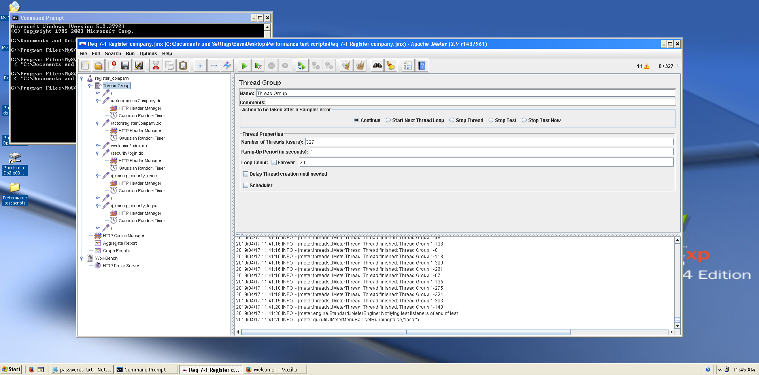

Figura 1. Configuration

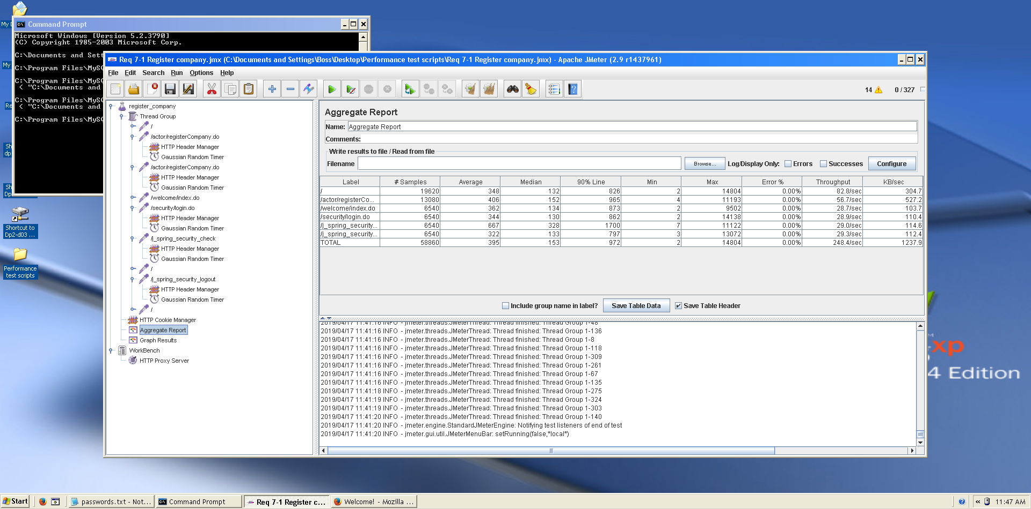This is the maximum workload of the test case without any crash or excesive delay. As we can see in the picture below, we don’t have any errors and the average time per request is pretty acceptable.

Figura 2. Aggregate Report

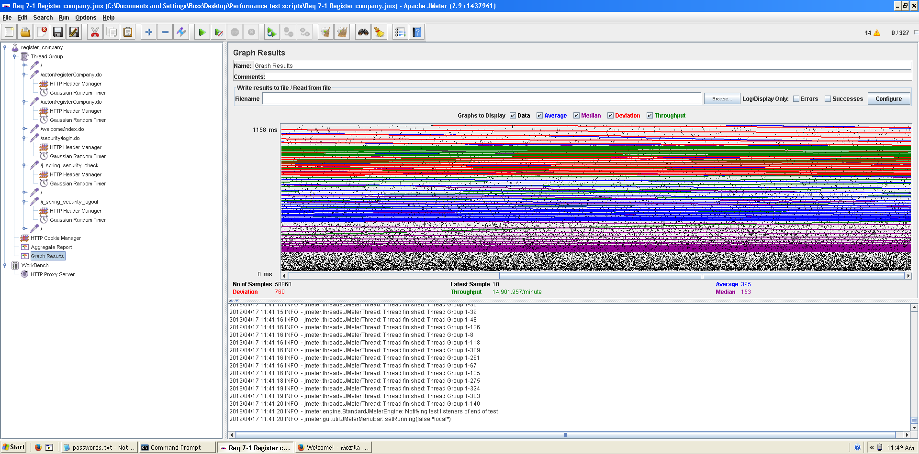

Figure 3. Stabilized output graph report

**Overload test case:** 335 concurrent users and 20 of loop count:

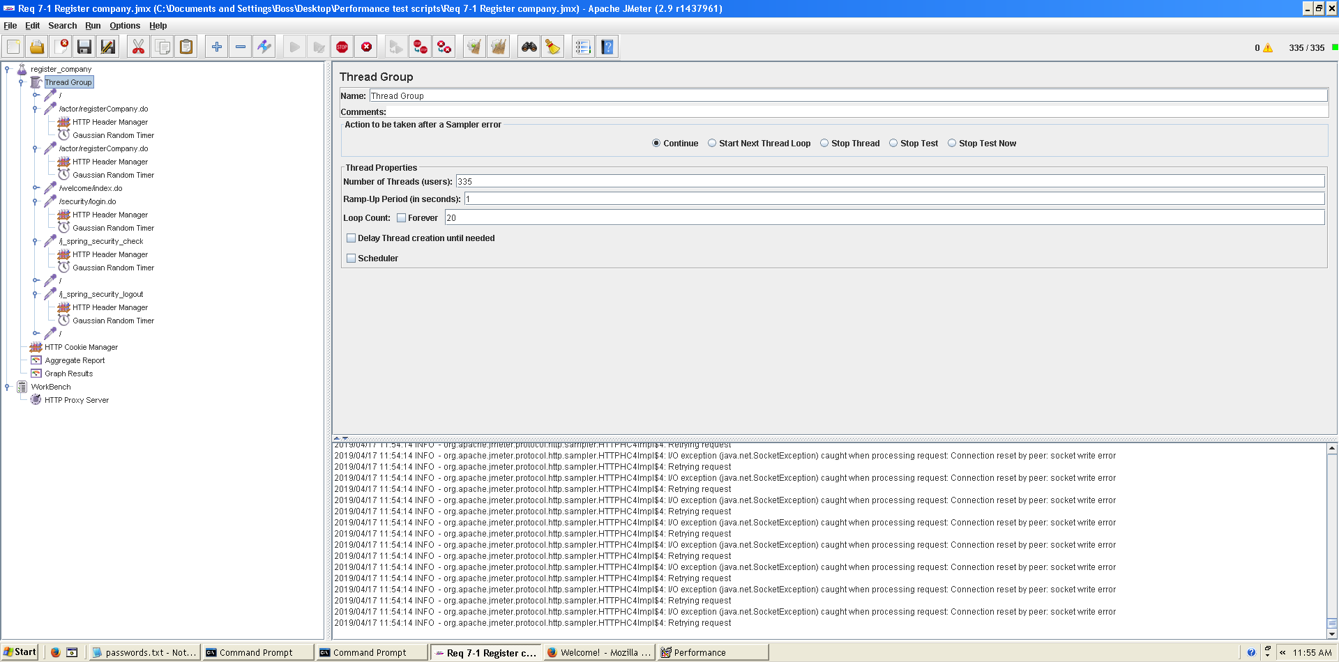

Figure 4. Configuration

Even though the average time per request is still acceptable, it begins to produce some errors as we can see in the following picture. The errors are always the same: I/O exception (java.net.BindException) caught when connecting to the target host:

Address already in use: connect This exception is not related with the implementation of our application, but with tomcat. The system can’t handle this number of concurrent users properly.

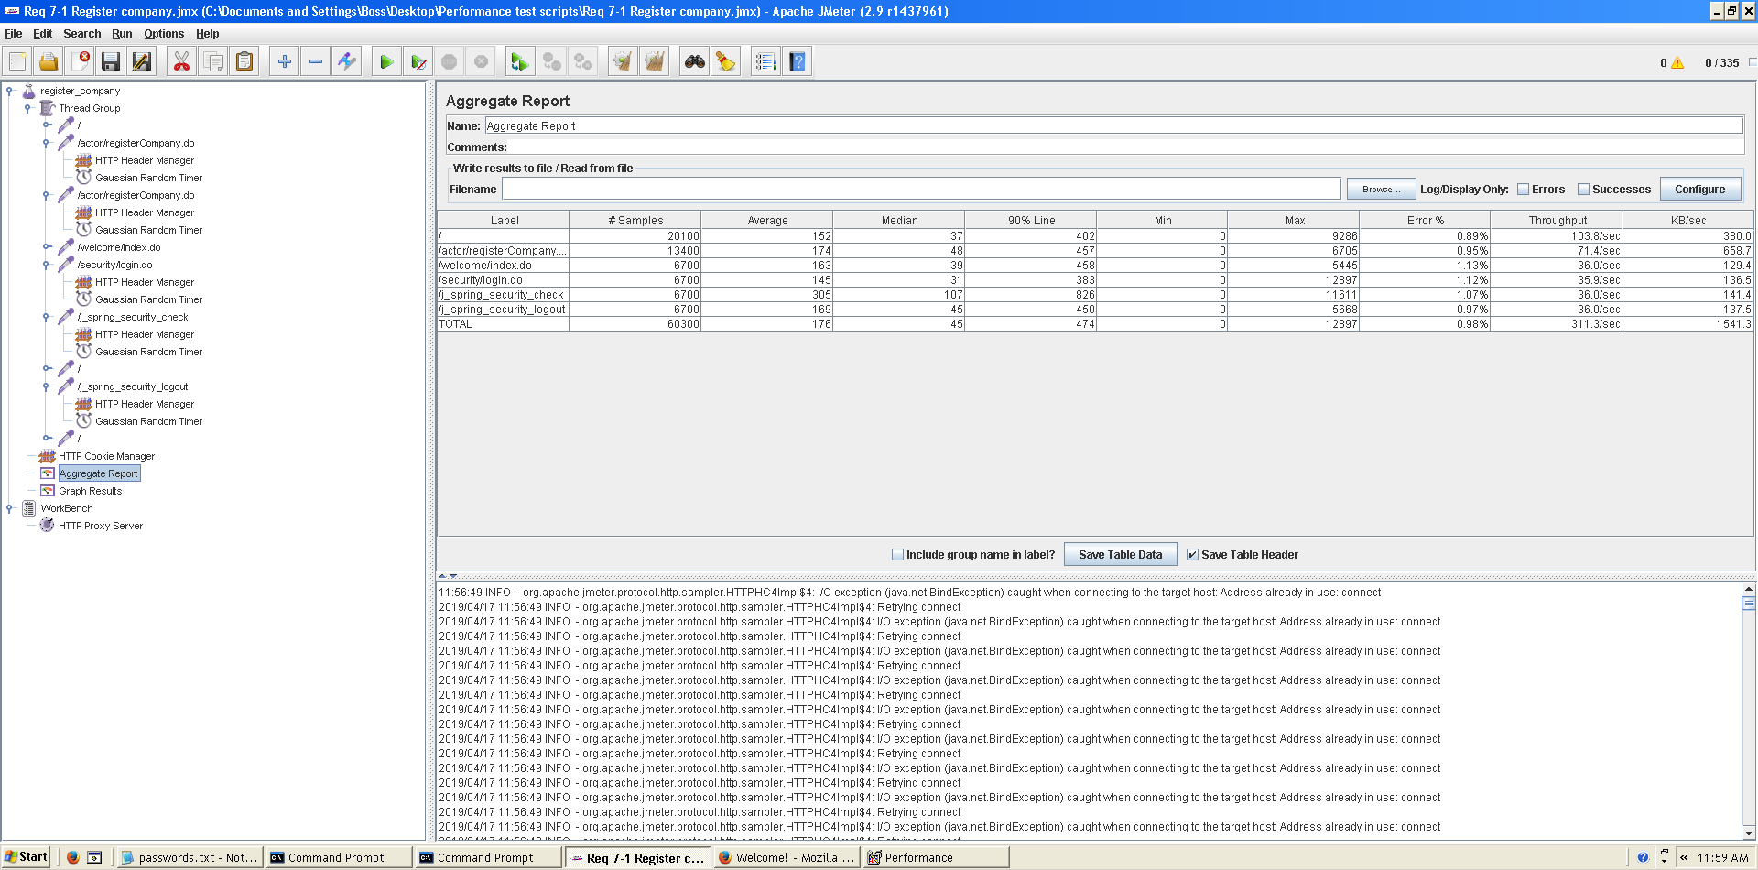

Figure 5. Aggregate report

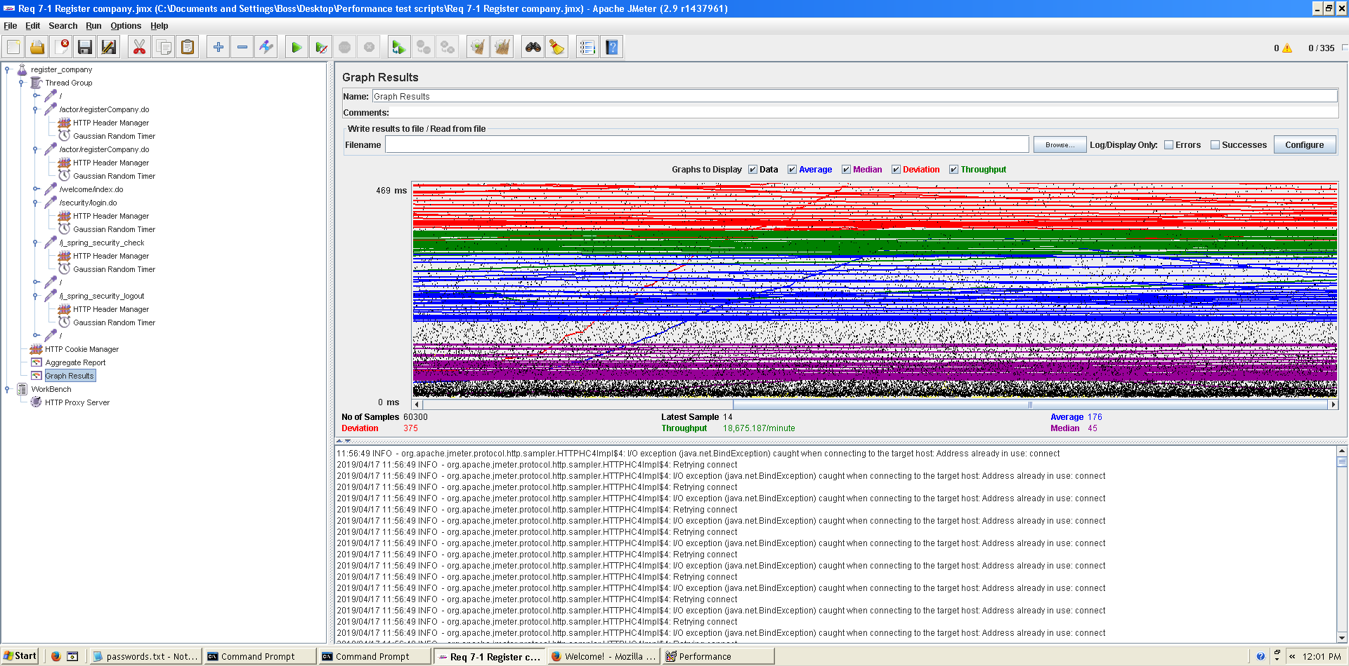

Figure 6. Stabilized output graph report

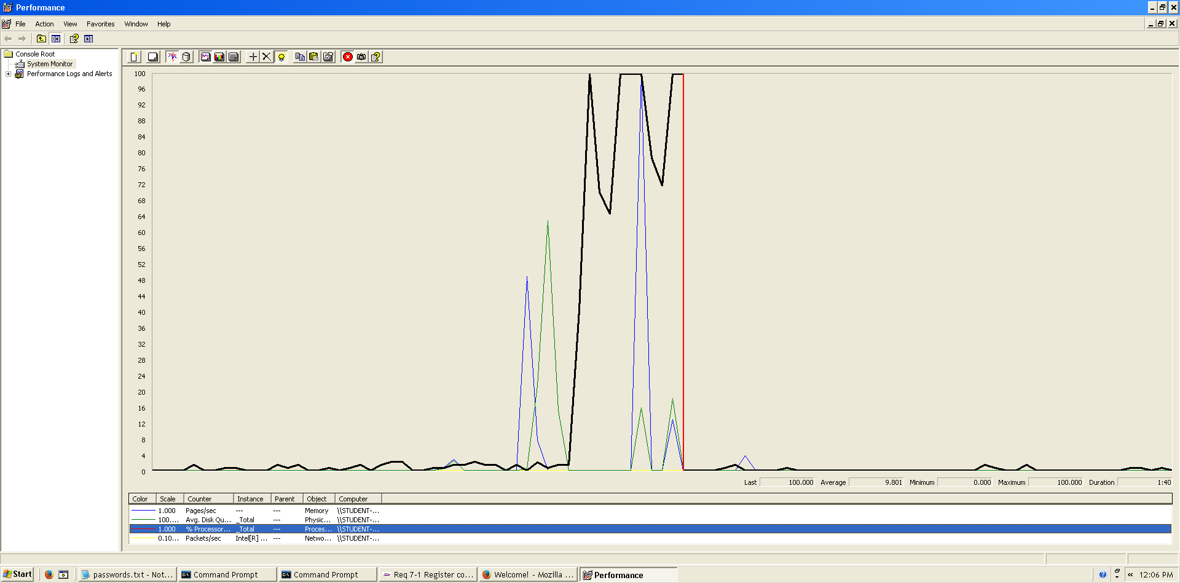As we can see in the graph below, there is a bottleneck with the CPU. Probably we could improve the maximum workload of the application if we assign more processors to the virtual machine.

Figure 7. Bottleneck analysis

**Conclusion:** The maximum number of concurrent users supported by this test case is 327 and we could improve it by assigning more CPU’s resources to our system.

**Req. 7.1** – An actor who is not authenticated must be able to: Register to the system as a hacker.

Technical details of the computer on which the test has been executed:

* Ram: 8,00 GB
* CPU: Intel Core i7-7700HQ
* Hard disk: 256 GB SSD + 921 GB HDD
* Network card: Intel(R) Dual Band Wireless-AC 3168

**Test case description**:

* The user goes to register hacker view.
* The user completes register hacker form.
* The user log in the system and then, log out.

**Maximum workload test case.** 340 concurrent users and 20 of loop count:

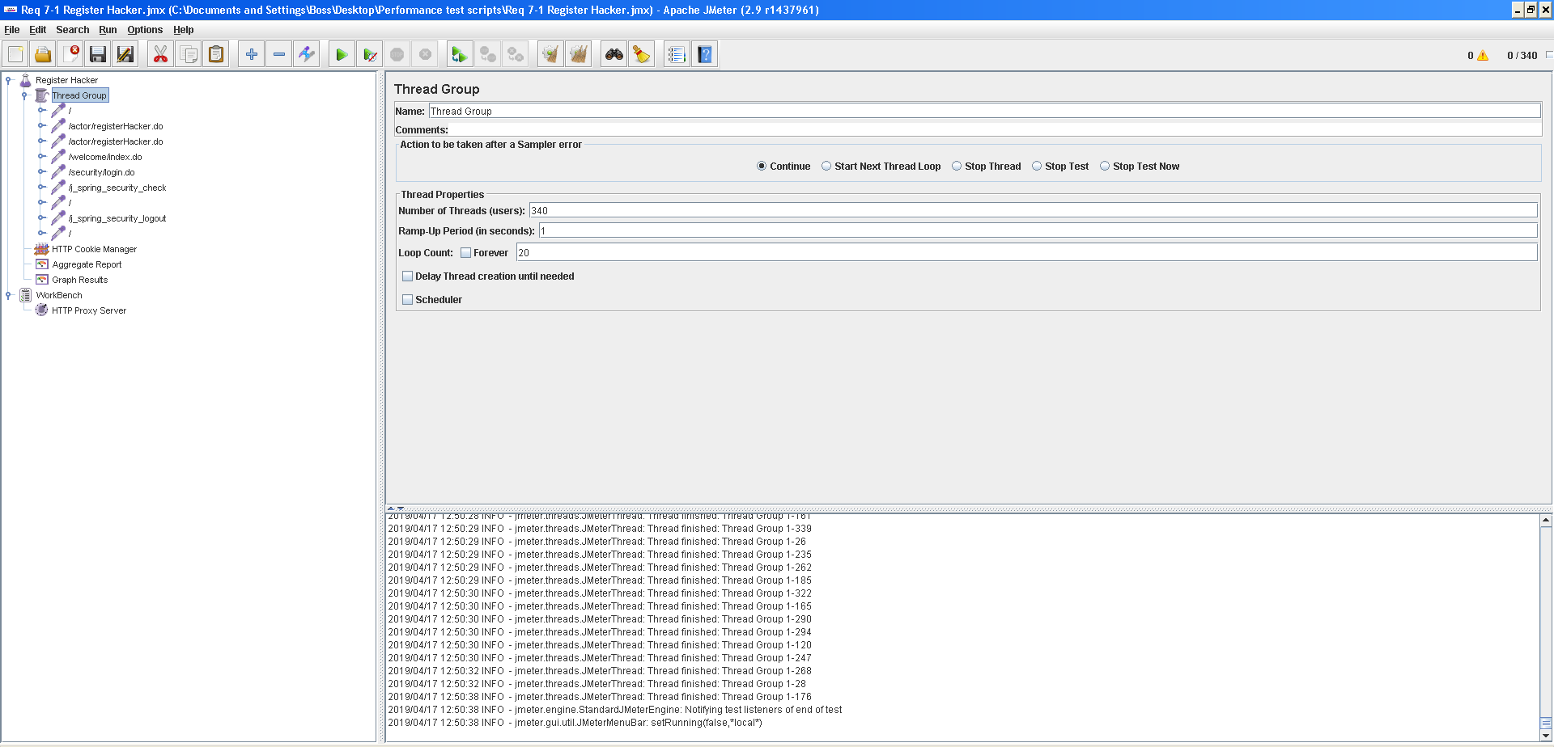

Figura 3. Configuration

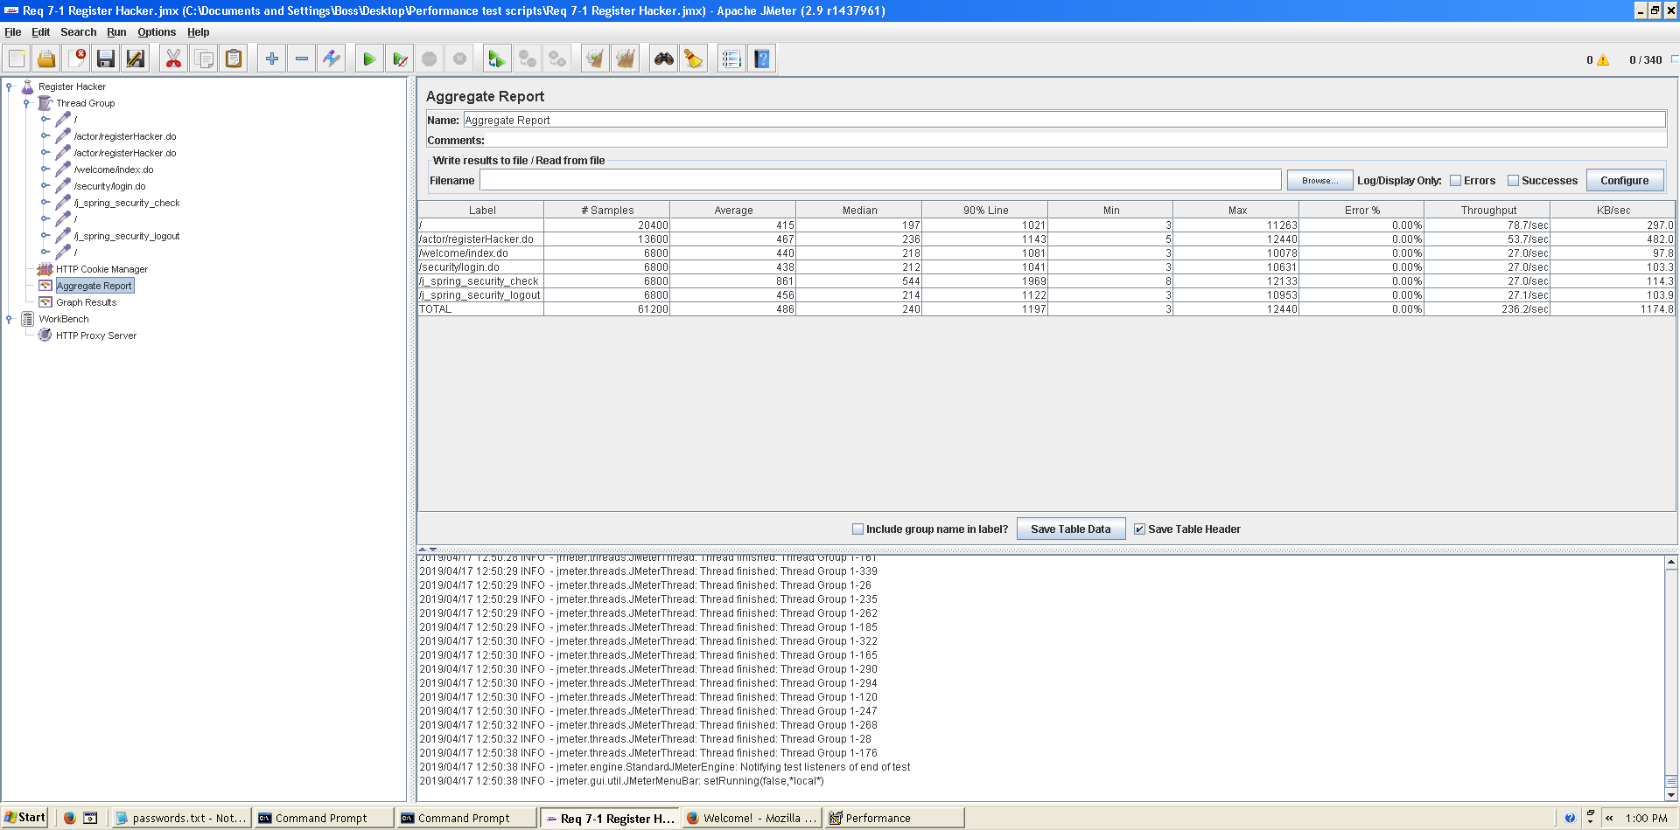This is the maximum workload of the test case without any crash or excesive delay. As we can see in the picture below, we don’t have any errors and the average time per request is pretty acceptable.

Figura 4. Aggregate report

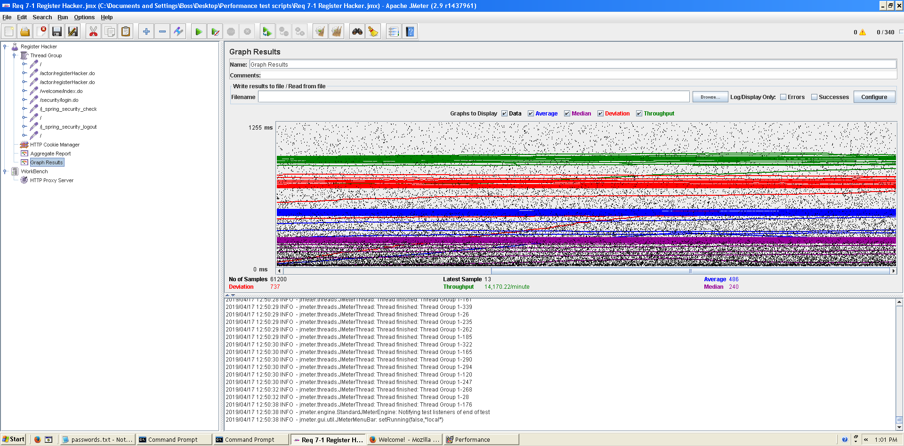

Figura 5. Graph result

**Overload test case:** 350 concurrent users and 20 of loop count:

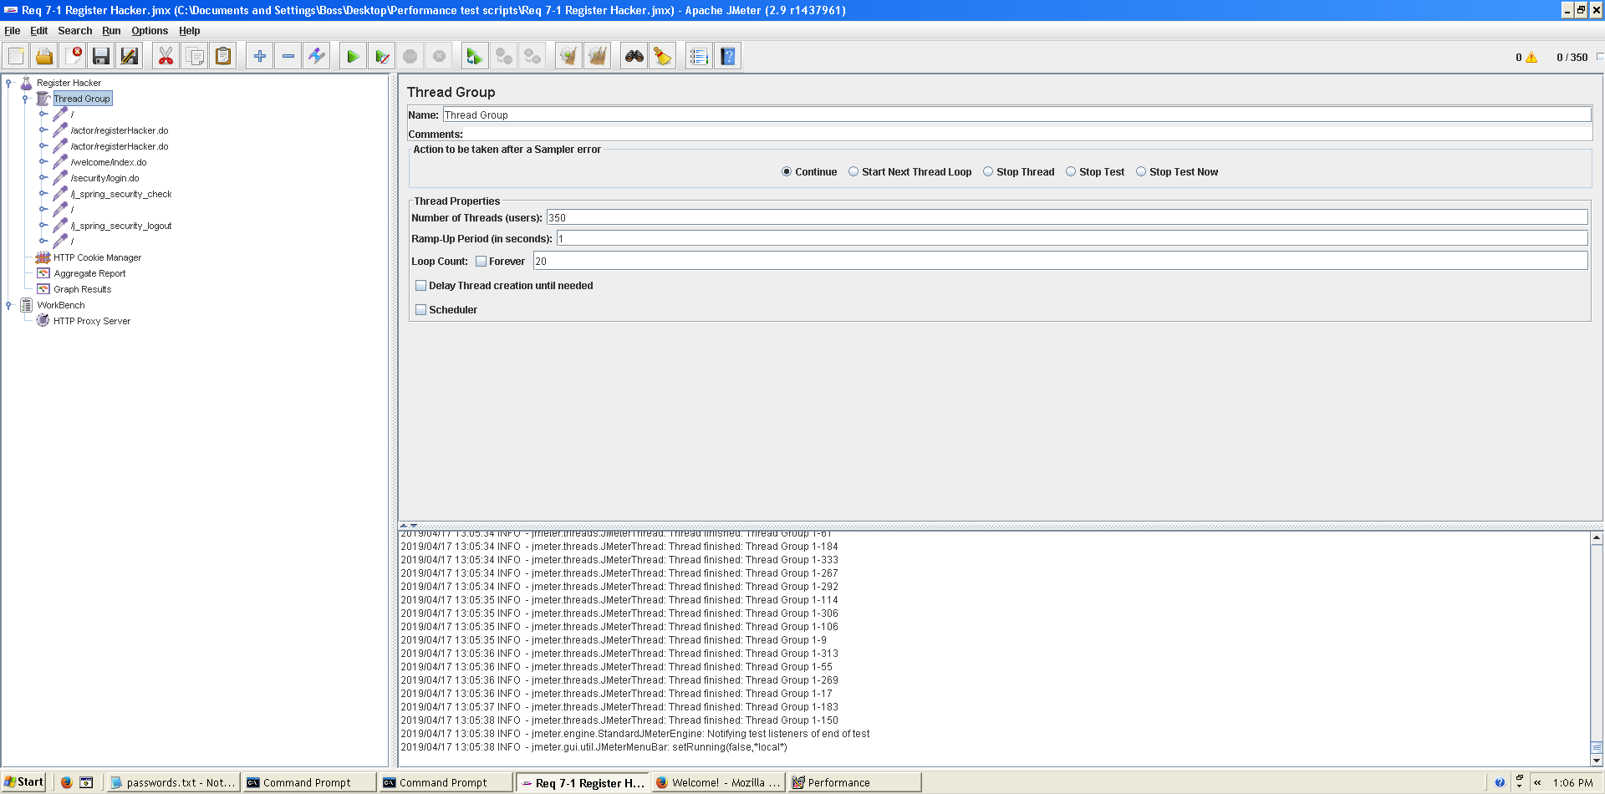

Figura 6. Configuration

Even though the average time per request is still acceptable, it begins to produce some errors as we can see in the following picture. The errors are always the same: I/O exception (java.net.BindException) caught when connecting to the target host:

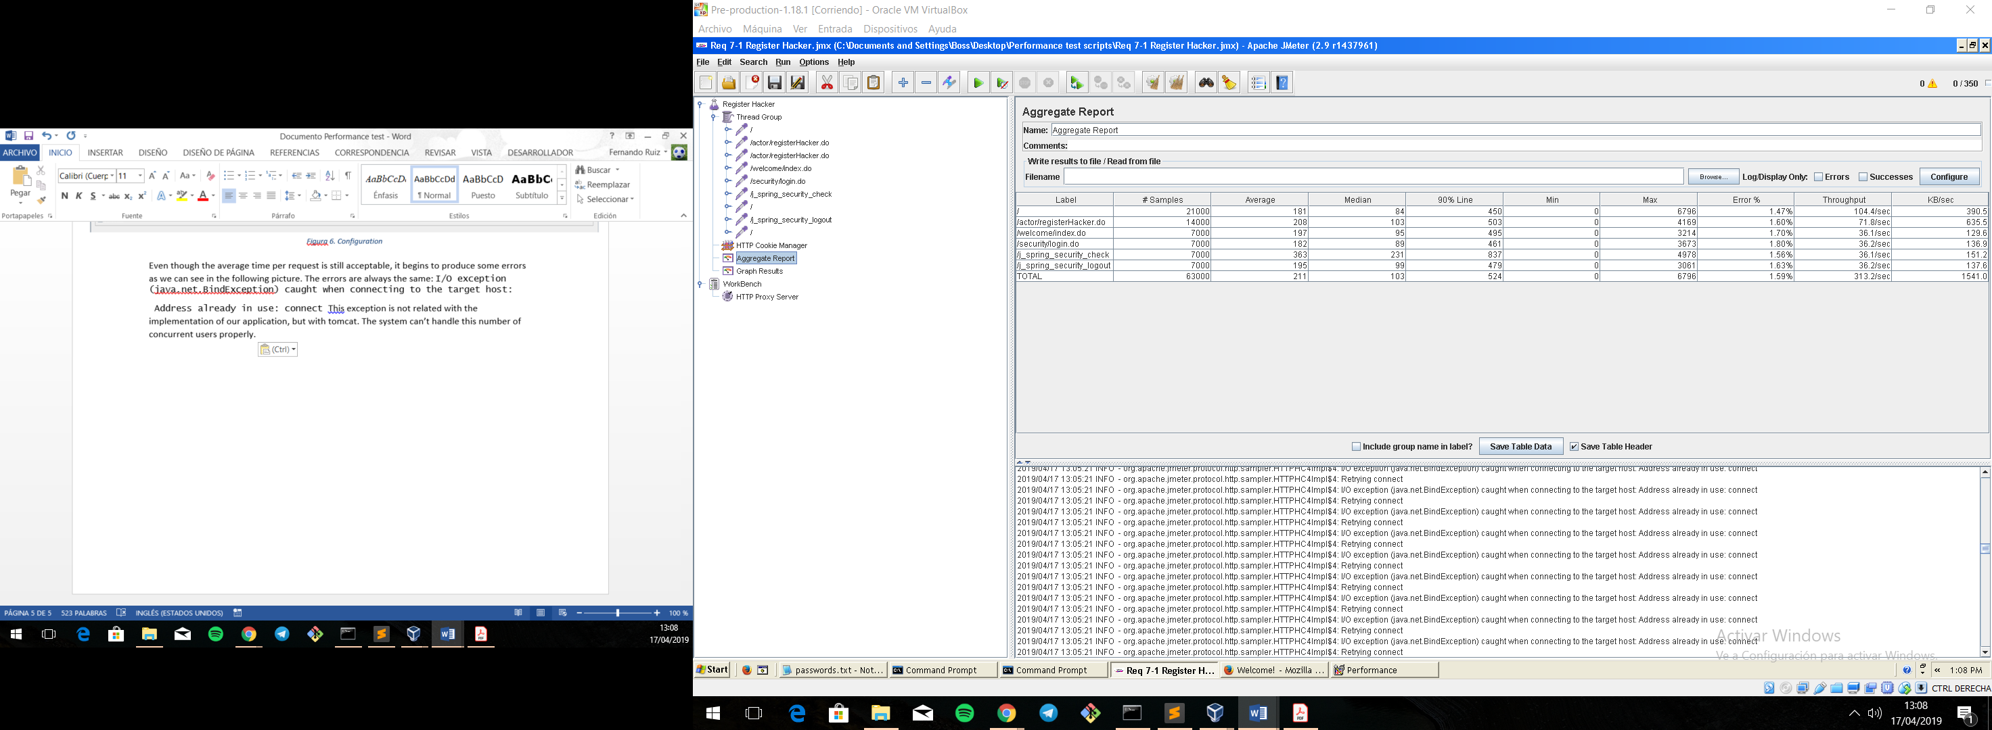 Address already in use: connect This exception is not related with the implementation of our application, but with tomcat. The system can’t handle this number of concurrent users properly.

Figura 7. Aggregate Report

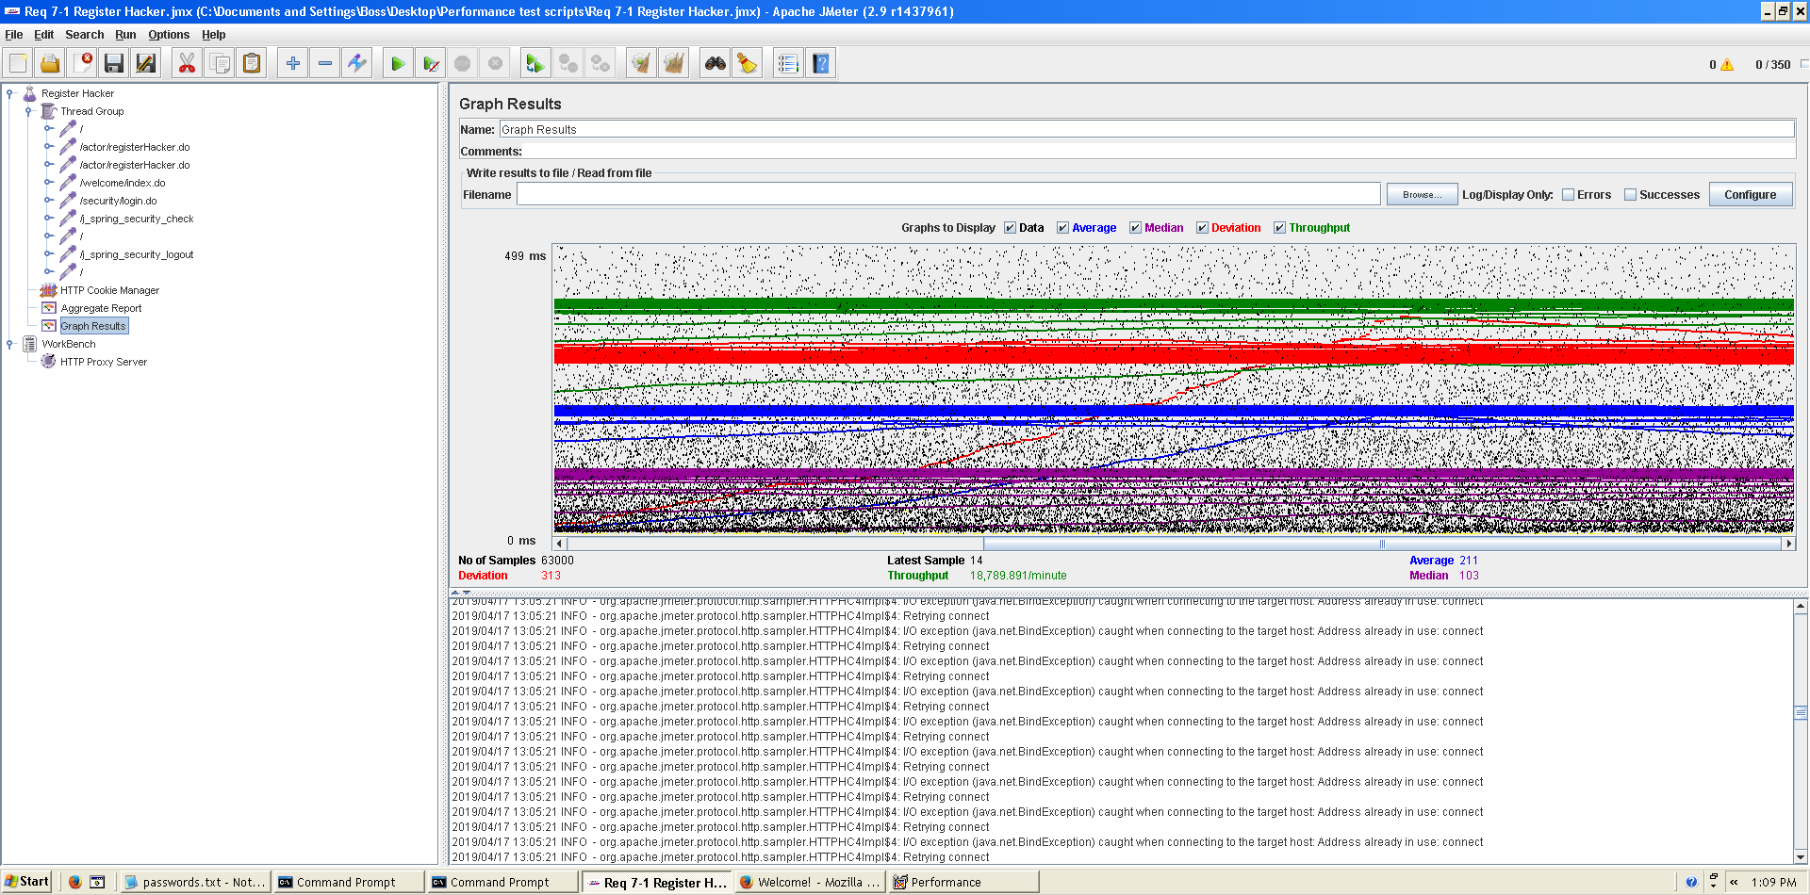  
  
As we can see in the graph below, there is a bottleneck with the CPU. We could improve CPU’s resources because, as we can see it almost works at 100%.

Figura 8. Graph result

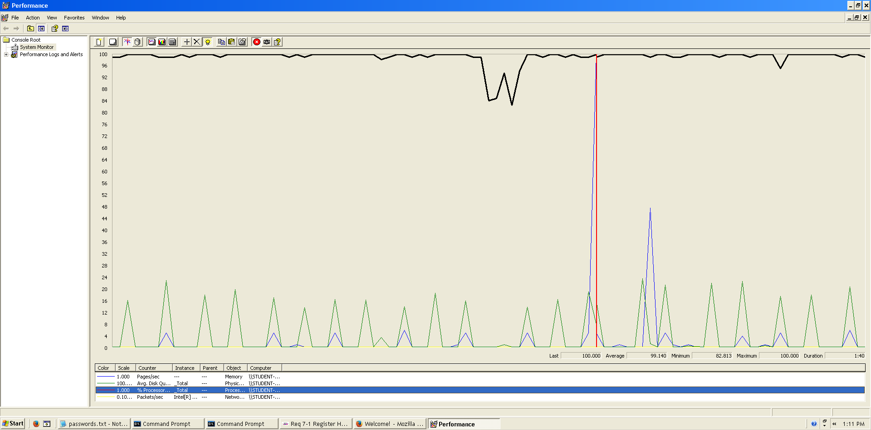

Figura 9. Bottleneck analysis

**Conclusion:** The maximum number of concurrent users supported by this test case is 340 and we could improve it by assigning more CPU’s resources to our system.

**Req. 7.3** – An actor who is not authenticated must be able to: List the companies available and navigate to the corresponding positions.

Technical details of the computer on which the test has been executed:

* Ram: 8,00 GB
* CPU: Intel Core i7-7700HQ
* Hard disk: 256 GB SSD + 921 GB HDD
* Network card: Intel(R) Dual Band Wireless-AC 3168

**Test case description**:

* The user goes to company list view.
* The user display a company from the list.
* The user display de positions of the company.

**Maximum workload test case.** 485 concurrent users and 20 of loop count:

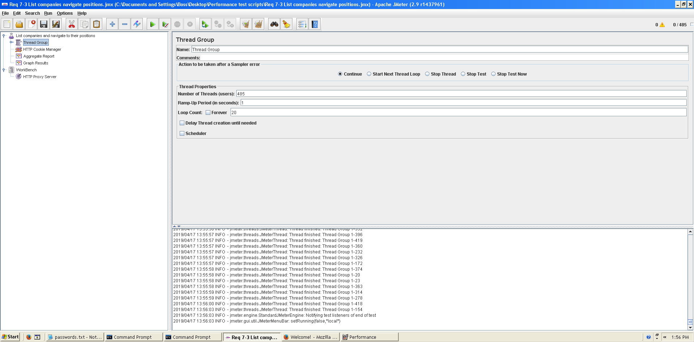

Figura 10. Configuration

This is the maximum workload of the test case without any crash or excesive delay. As we can see in the picture below, we don’t have any errors and the average time per request is pretty acceptable.

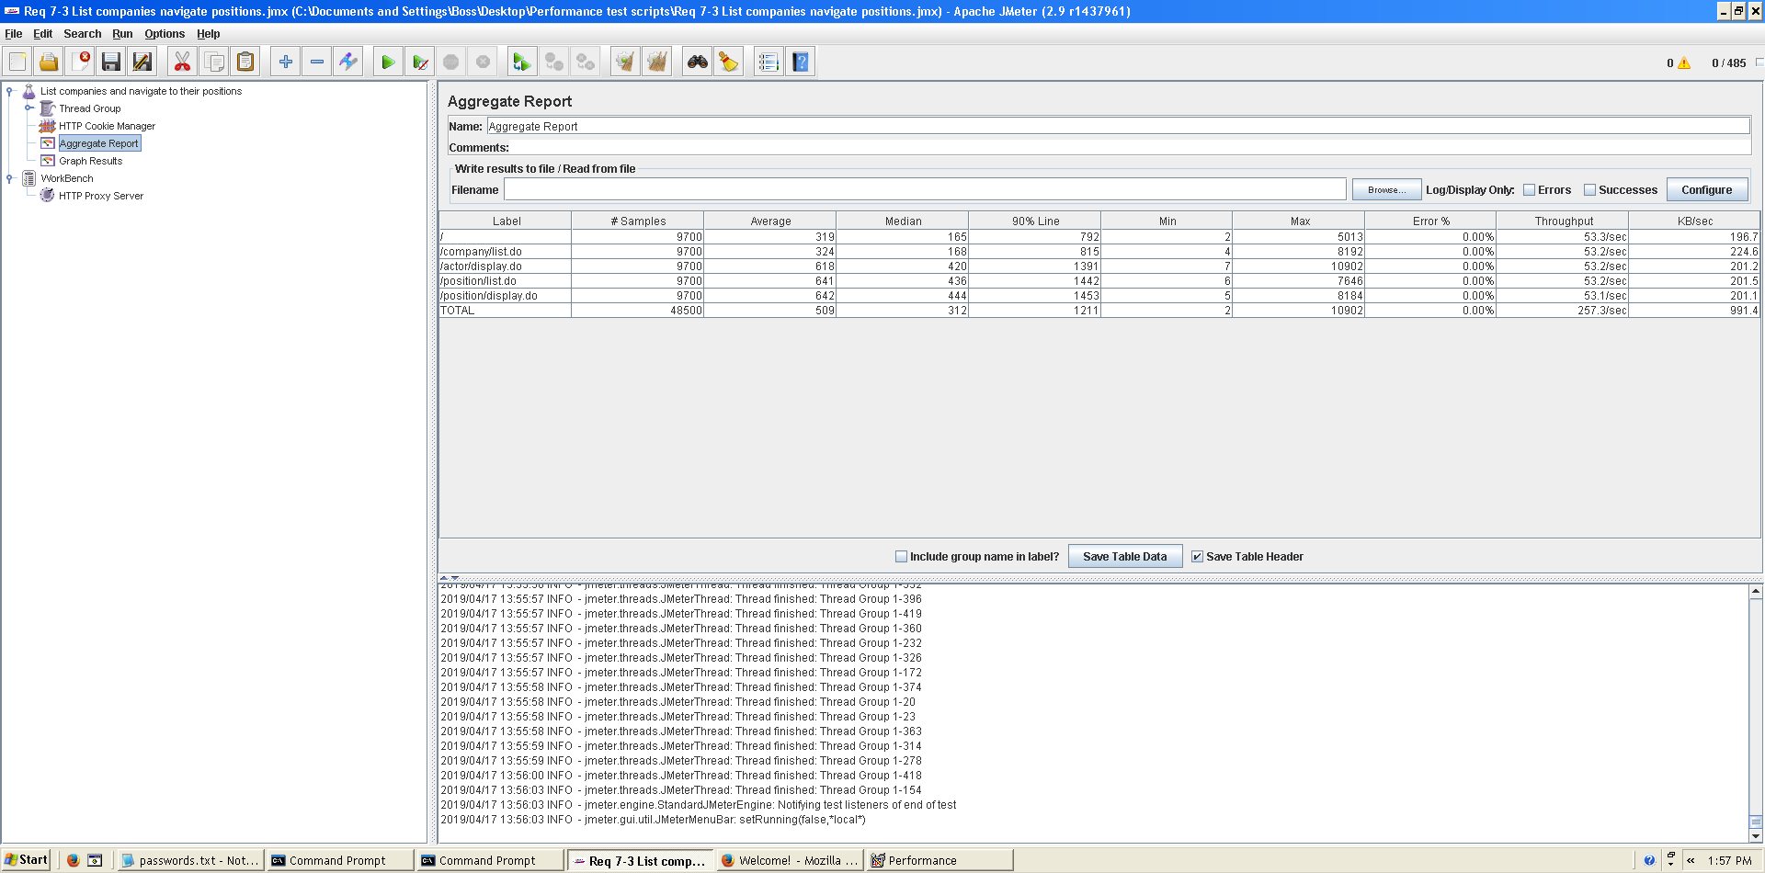

Figura 11. Aggregate Report

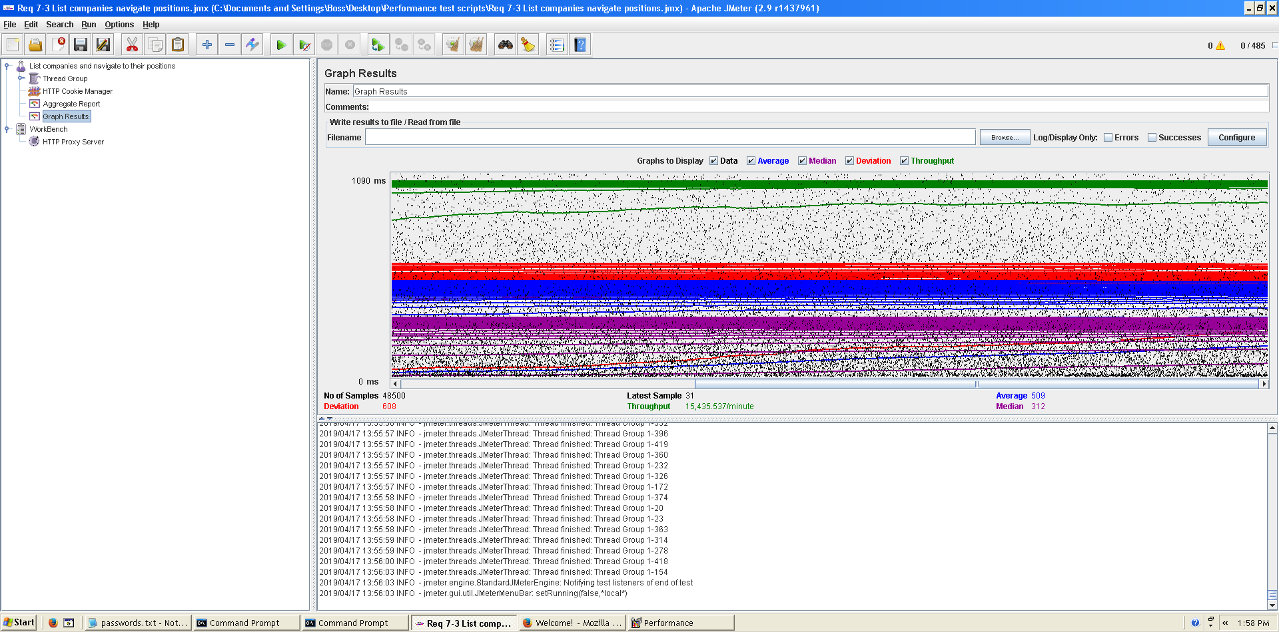

Figura 12. Graph result

**Overload test case:** 495 concurrent users and 20 of loop count:

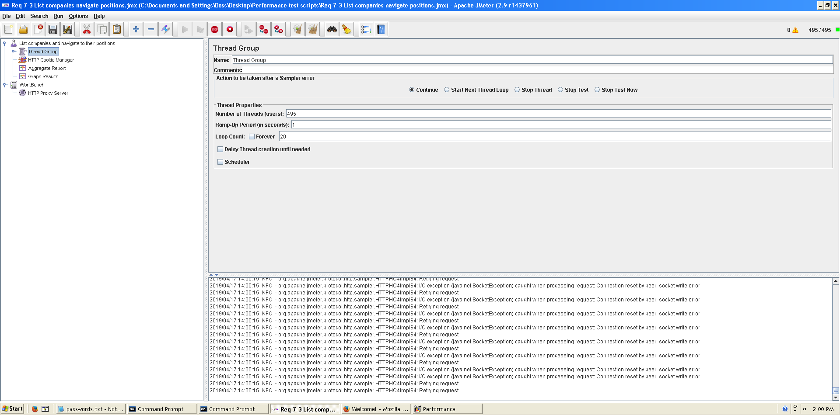

Figura 13. Configuration

Even though the average time per request is still acceptable, it begins to produce some errors as we can see in the following picture. The errors are always the same: I/O exception (java.net.SocketException) caught when processing request: Connection reset by peer: socket write error This exception is not related with the implementation of our application, but with tomcat. The system can’t handle this number of concurrent users properly.

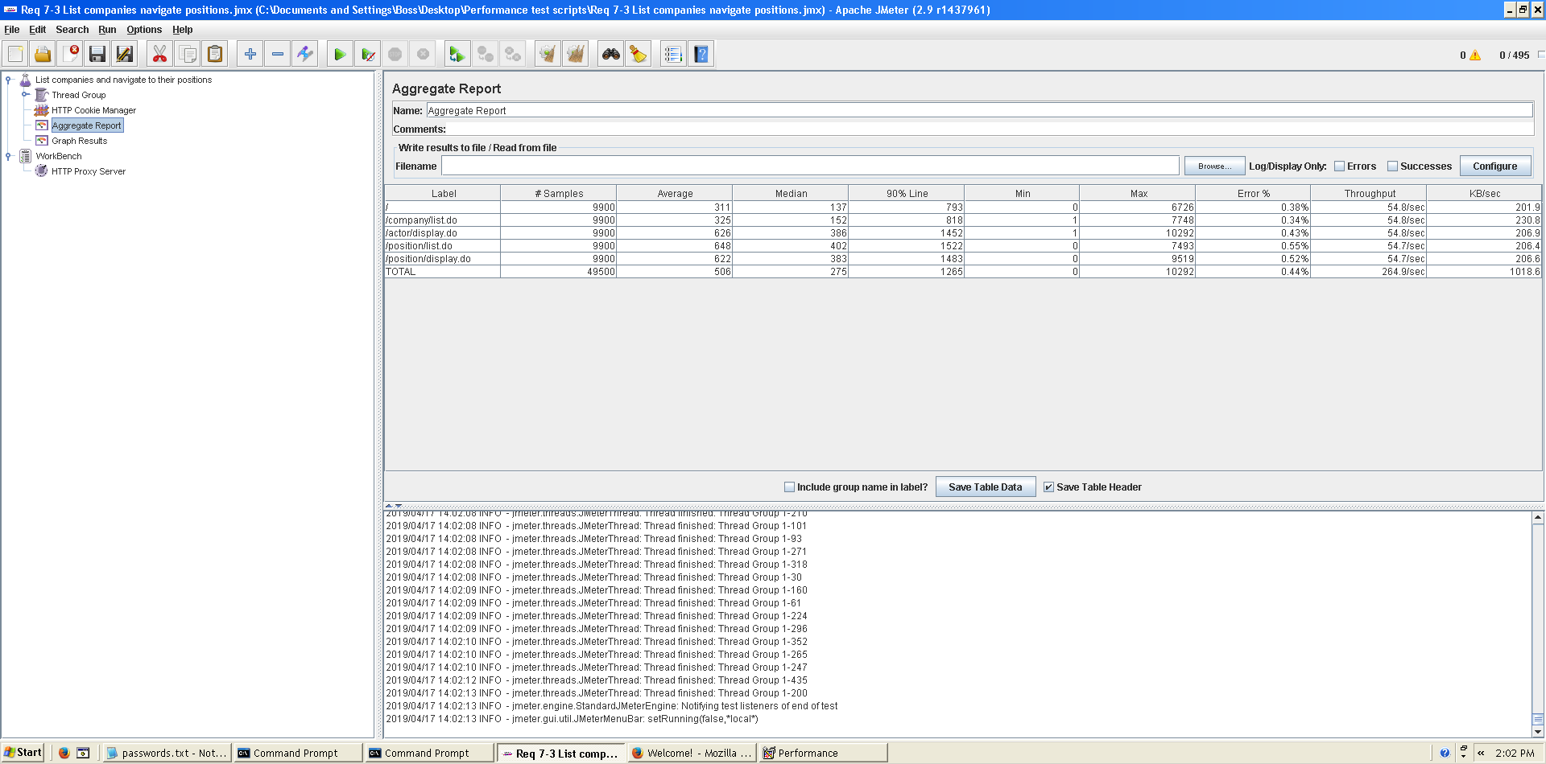

Figura 14. Aggregate Report

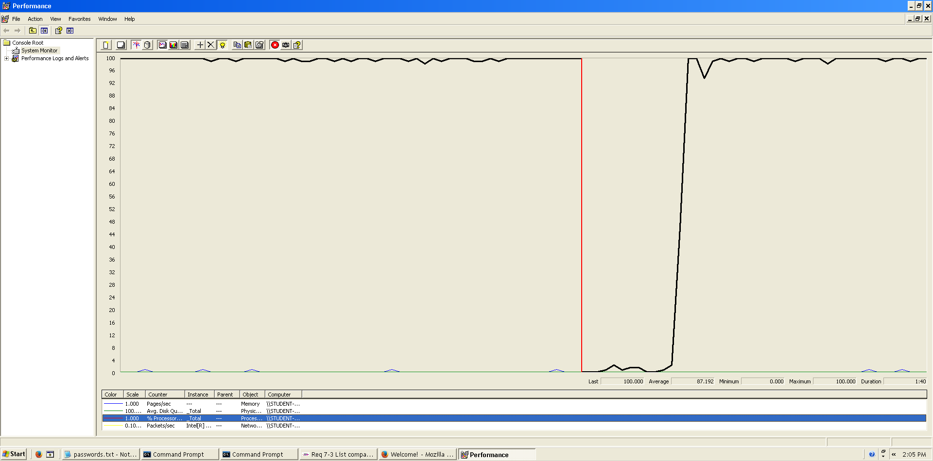As we can see in the graph below, there is a bottleneck with the CPU. Probably we could improve the maximum workload of the application if we assign more processors to the virtual machine but not improve it so much because we can see it doesn’t work at 100% always.  
  
  
  
  
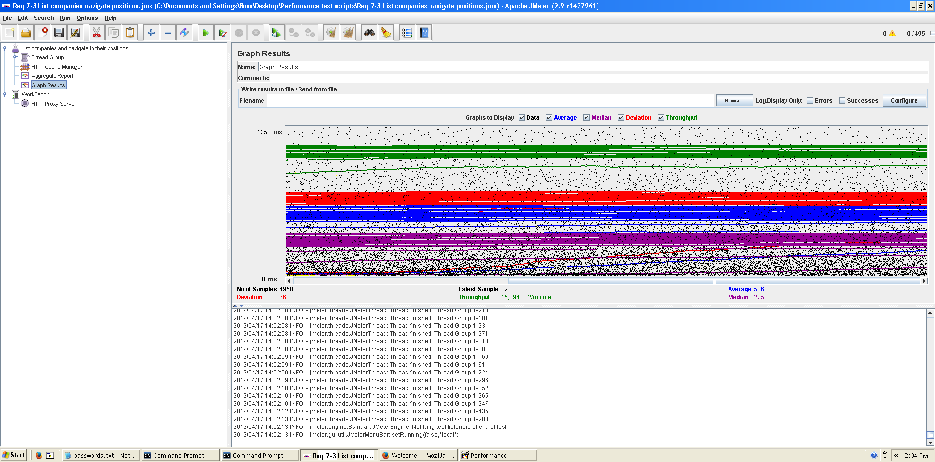 **Conclusion:** The maximum number of concurrent users supported by this test case is 485 and we could improve it by assigning more CPU’s resources to our system.

Figura 15. Bottleneck analysis

Figura 16. Graph result

**Req. 8.2** – An actor who is authenticated must be able to: Edit his or her personal data (administrator).

Technical details of the computer on which the test has been executed:

* Ram: 8,00 GB
* CPU: Intel Core i7-7700HQ
* Hard disk: 256 GB SSD + 921 GB HDD
* Network card: Intel(R) Dual Band Wireless-AC 3168

**Test case description**:

* The user log in the system.
* The user goes to his/her profile.
* The user goes to personal edit form.
* Change any field.
* Press save button save changes.
* Log out the system.

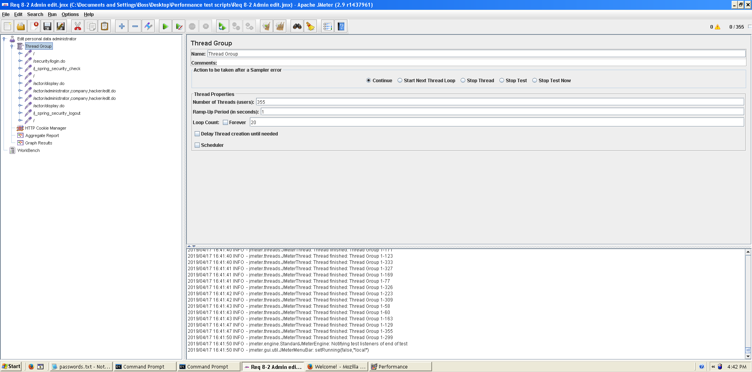**Maximum workload test case.** 355 concurrent users and 20 of loop count:

Figura 17. Configuración

This is the maximum workload of the test case without any crash or excesive delay. As we can see in the picture below, we don’t have any errors and the average time per request is pretty acceptable.

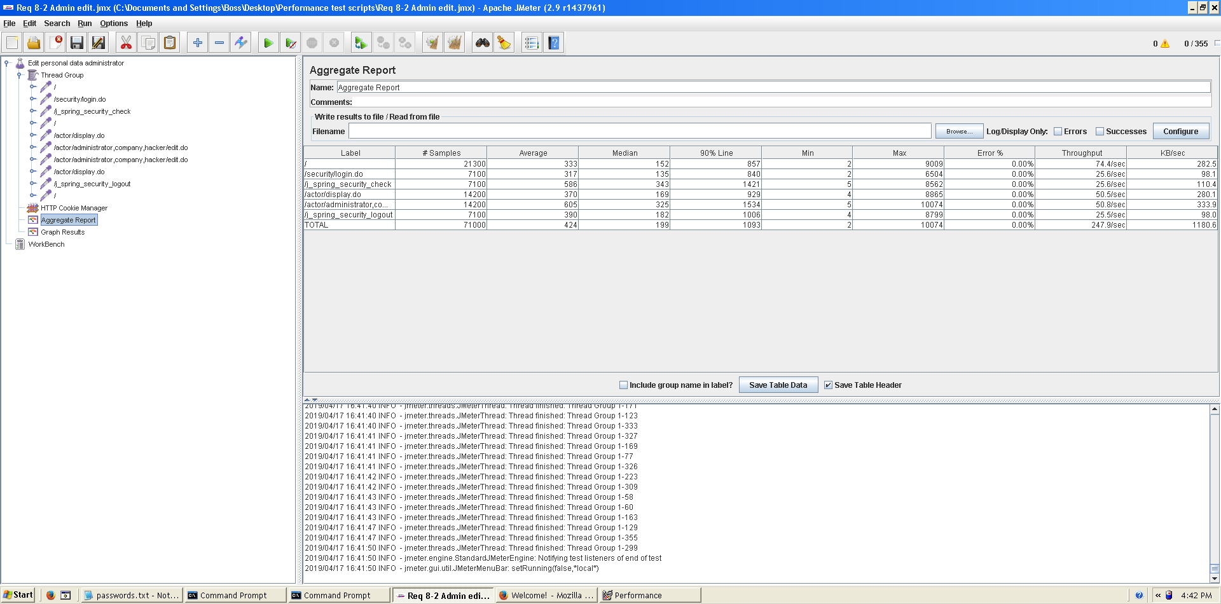

Figura 18. Aggregate Report

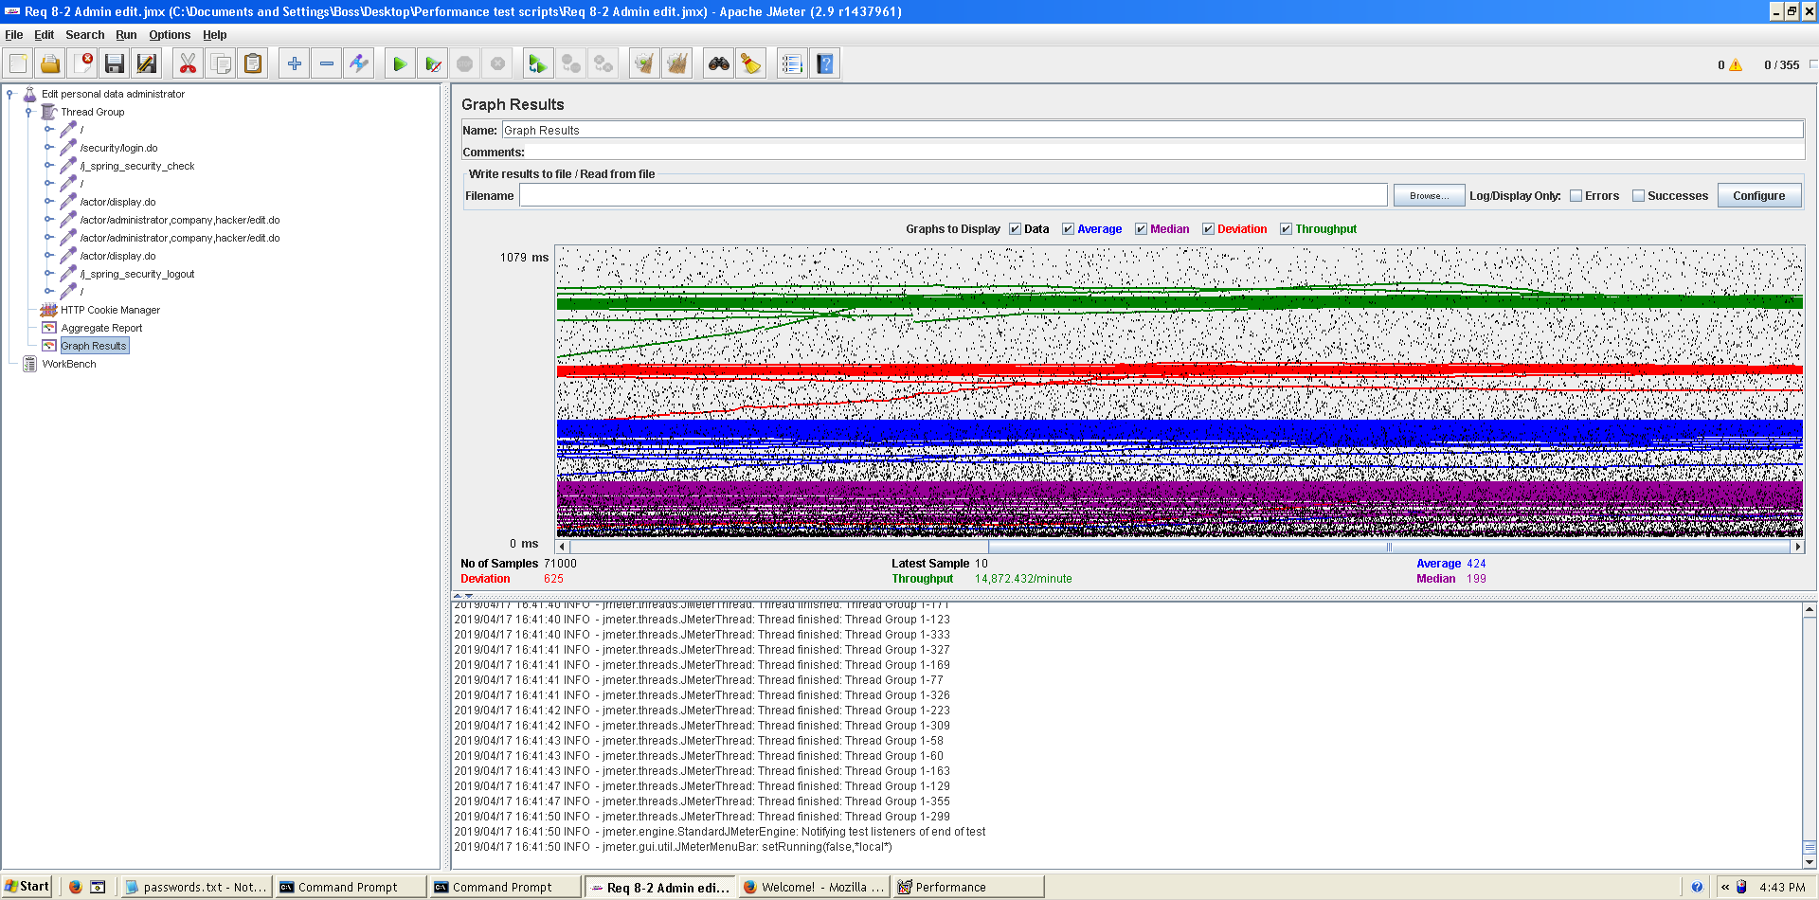

Figura 19. Graph result

**Overload test case:** 365 concurrent users and 20 of loop count:

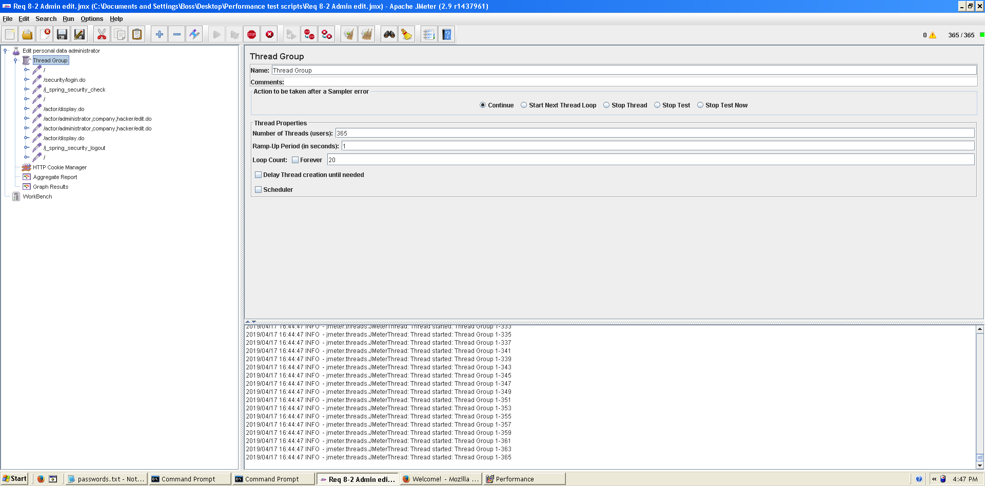

Figura 20. Configuration

Even though the average time per request is still acceptable, it begins to produce some errors as we can see in the following picture. The errors are always the same: I/O exception (java.net.SocketException) caught when processing request: Connection reset by peer: socket write error This exception is not related with the implementation of our application, but with tomcat. The system can’t handle this number of concurrent users properly.

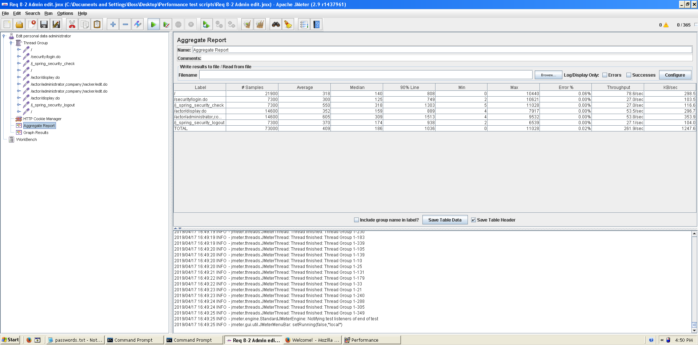

Figura 21. Aggregate Report

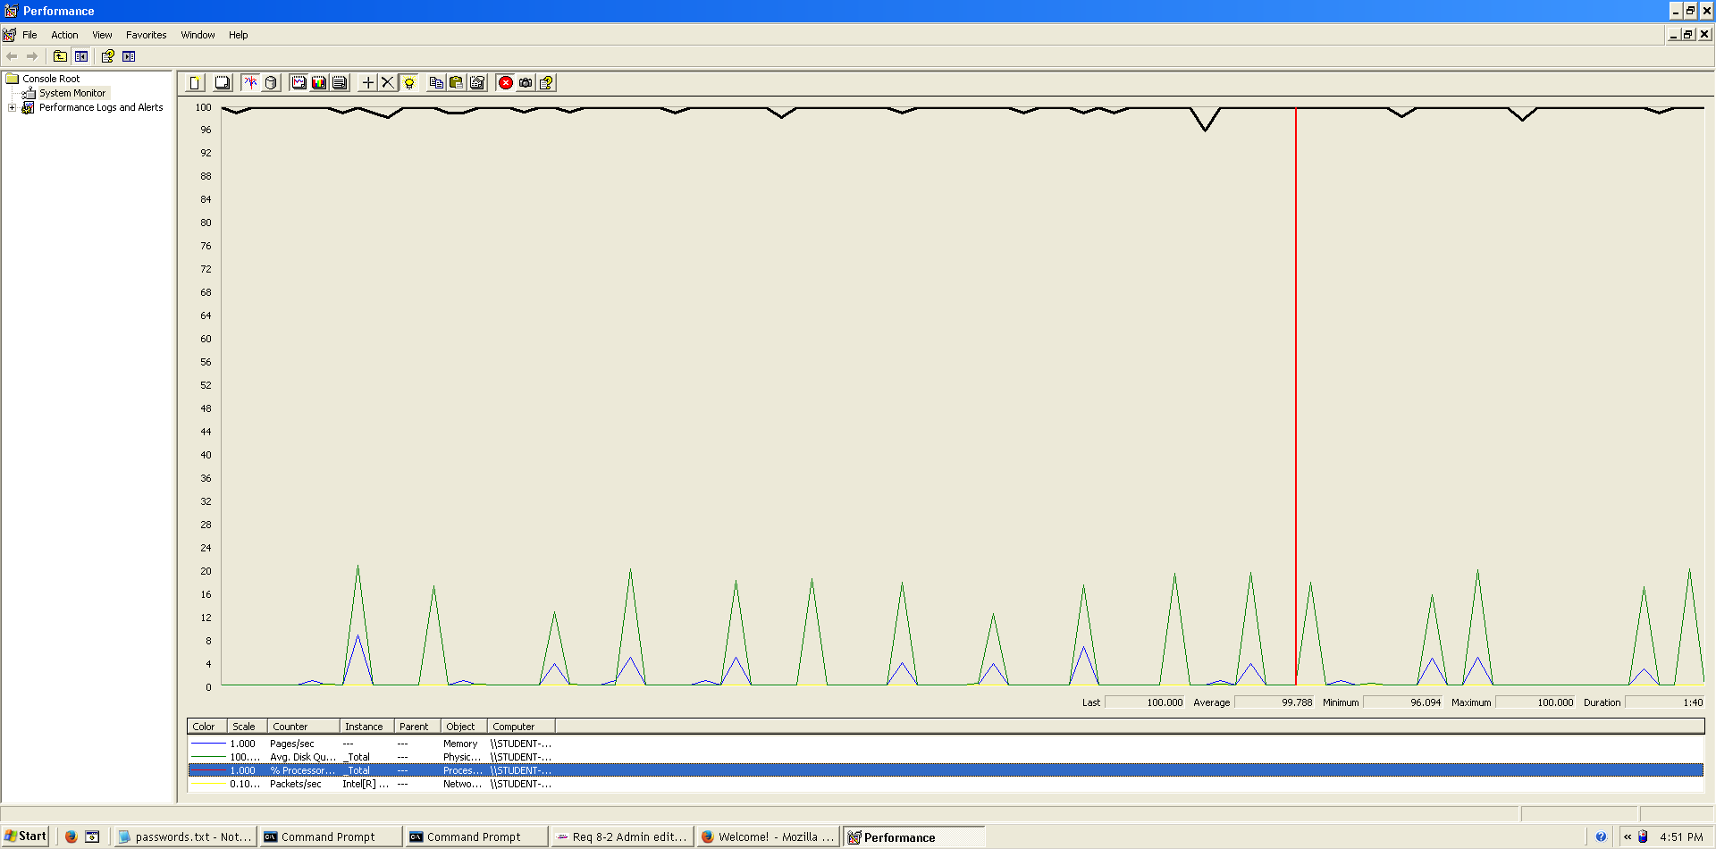As we can see in the aggregate report, there’s not so many errors, the maximum was 0.06% in the welcome view. In the graph below, there is a bottleneck with the CPU. Probably we could improve the maximum workload of the application if we assign more processors to the virtual machine.  
  
  
  
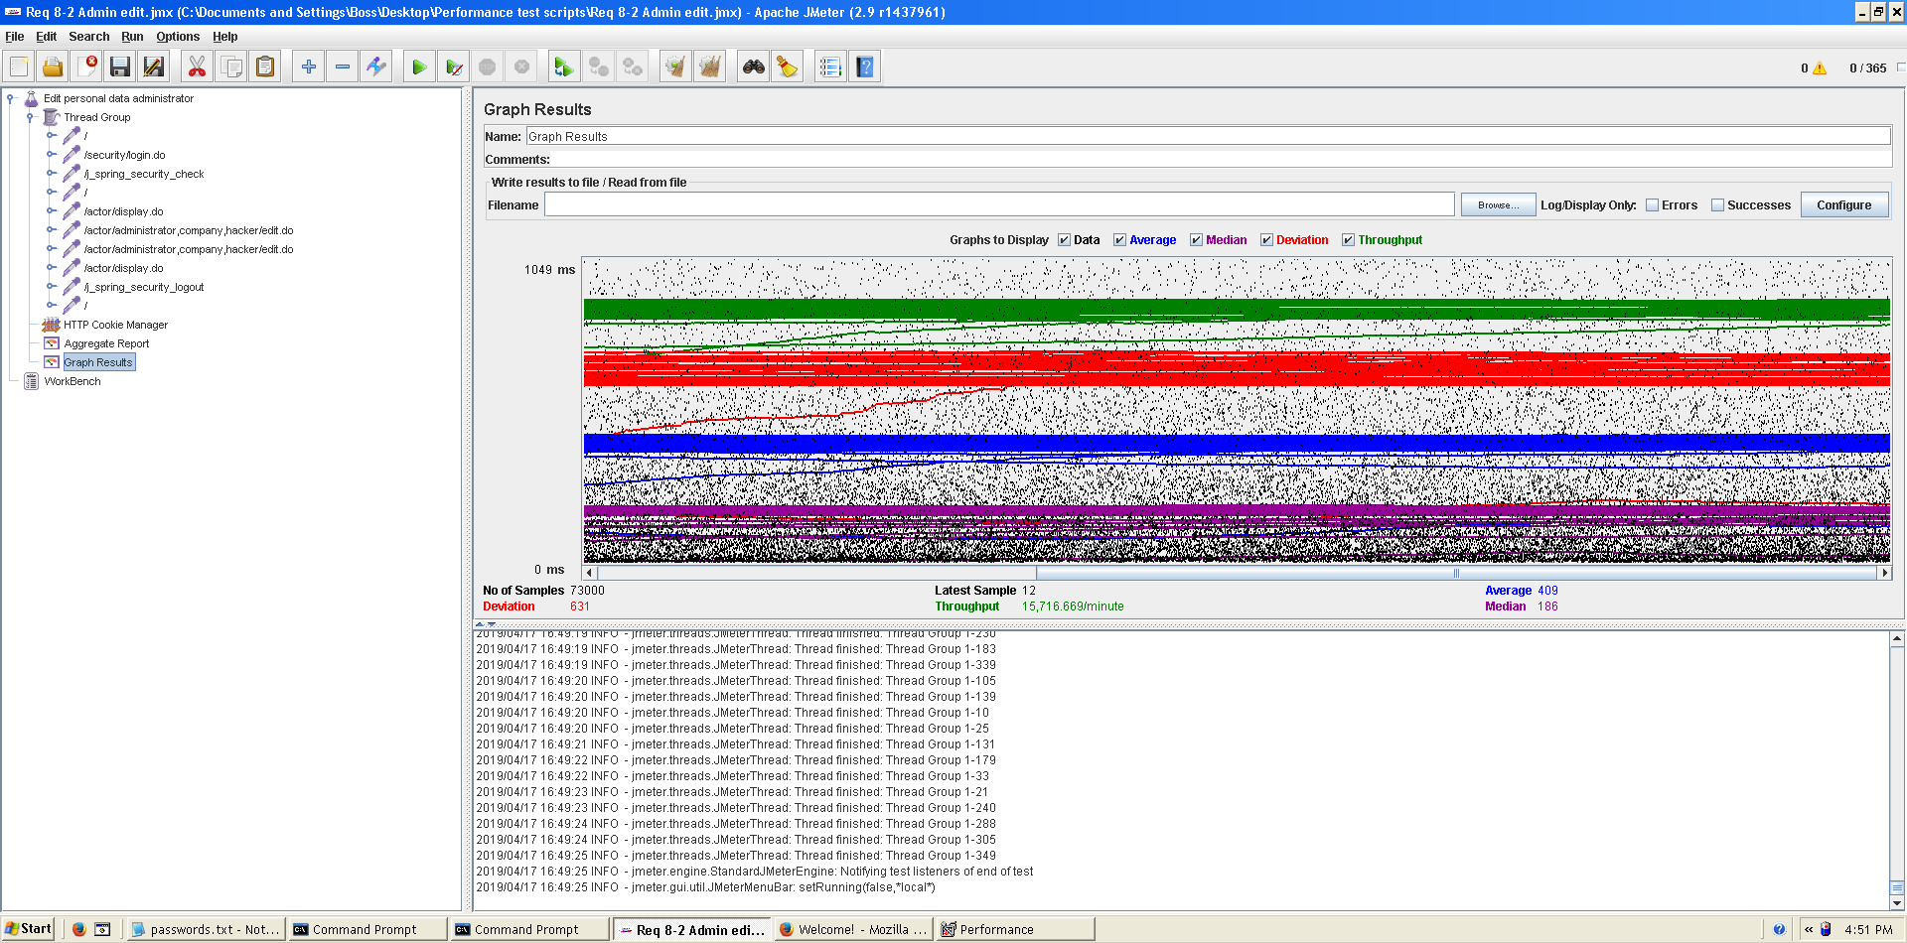**Conclusion:** The maximum number of concurrent users supported by this test case is 355 and we could improve it by assigning more CPU’s resources to our system.

Figura 22. Bottleneck analysis

Figura 23. Graph result

**Req. 8.2** – An actor who is authenticated must be able to: Edit his or her personal data (company).

Technical details of the computer on which the test has been executed:

* Ram: 8,00 GB
* CPU: Intel Core i7-7700HQ
* Hard disk: 256 GB SSD + 921 GB HDD
* Network card: Intel(R) Dual Band Wireless-AC 3168

**Test case description**:

* The user log in the system.
* The user goes to his/her profile.
* The user goes to personal edit form.
* Change any field.
* Press save button save changes.
* Log out the system.

**Maximum workload test case.** 370 concurrent users and 20 of loop count:

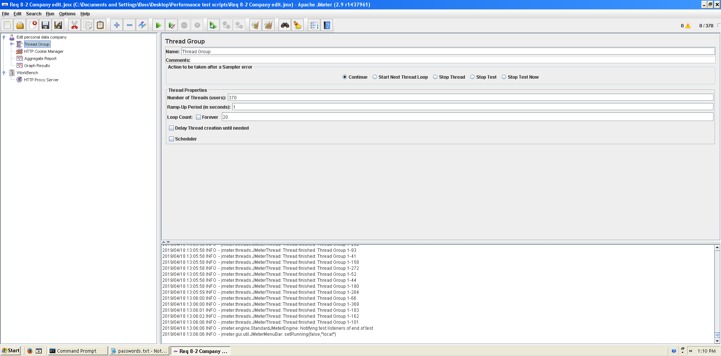

Figura 24. Configuation

This is the maximum workload of the test case without any crash or excesive delay. As we can see in the picture below, we don’t have any errors and the average time per request is pretty acceptable.

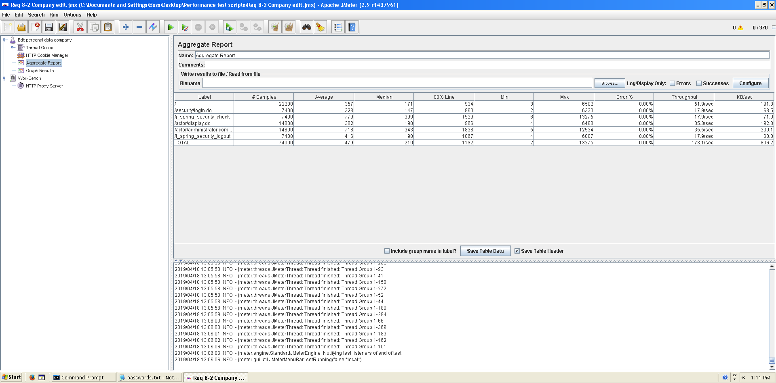

Figura 25. Aggreagate Report

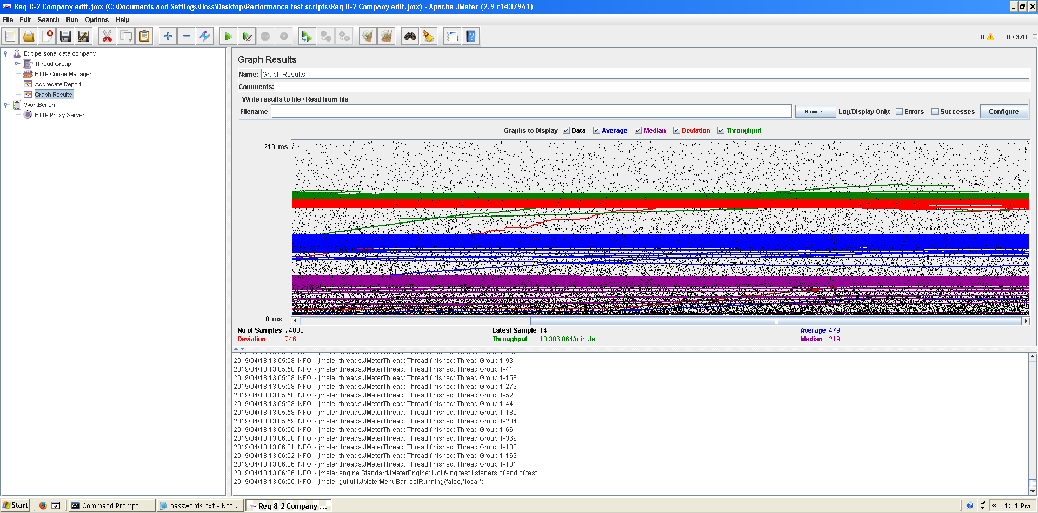

Figura 26.Graph result

**Overload test case:** 380 concurrent users and 20 of loop count:

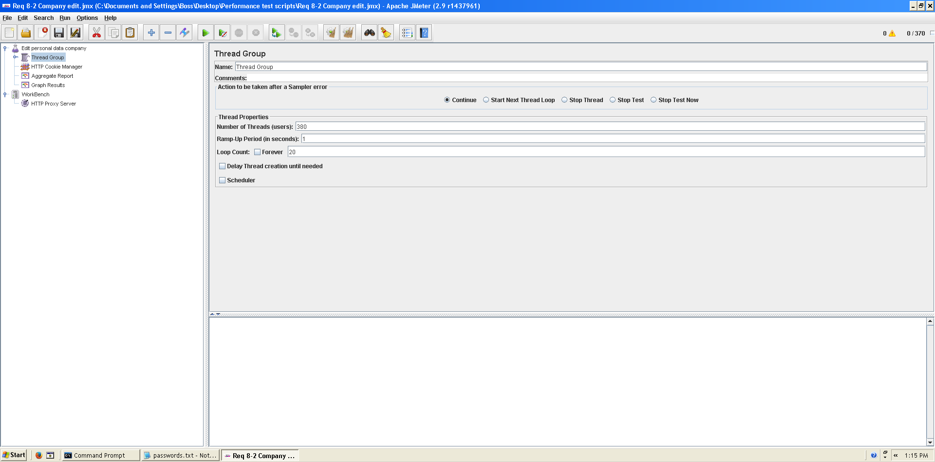

Figura 27. Configuration

It begins to produce some errors as we can see in the following picture. The errors are always the same: I/O exception (java.net.SocketException) caught when processing request: Connection reset by peer: socket write error This exception is not related with the implementation of our application, but with tomcat. The system can’t handle this number of concurrent users properly.

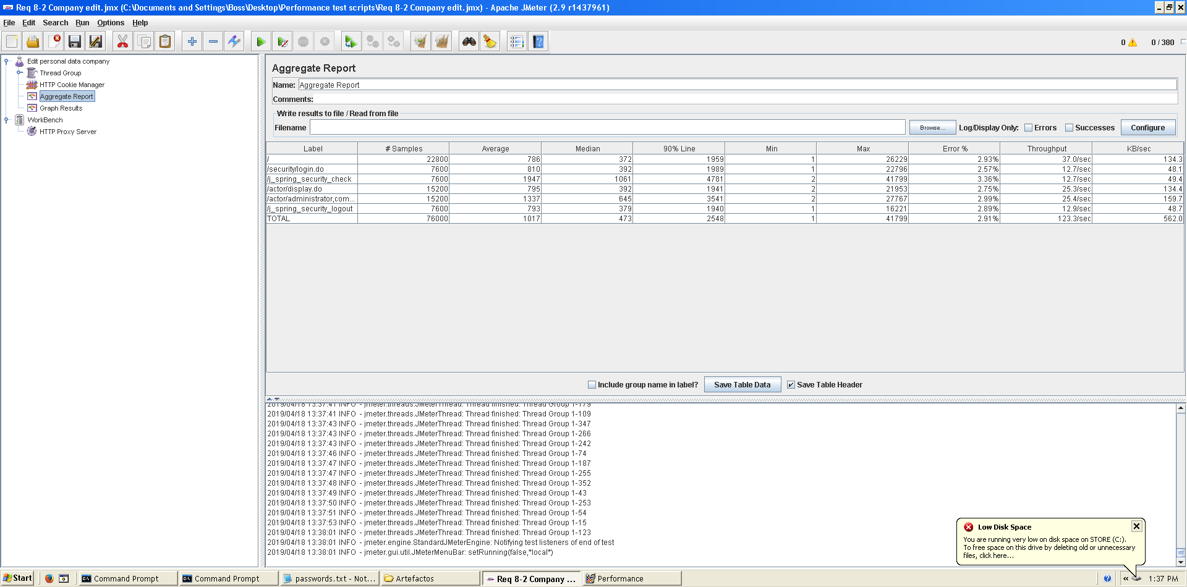

Figura 28, Aggregate Report

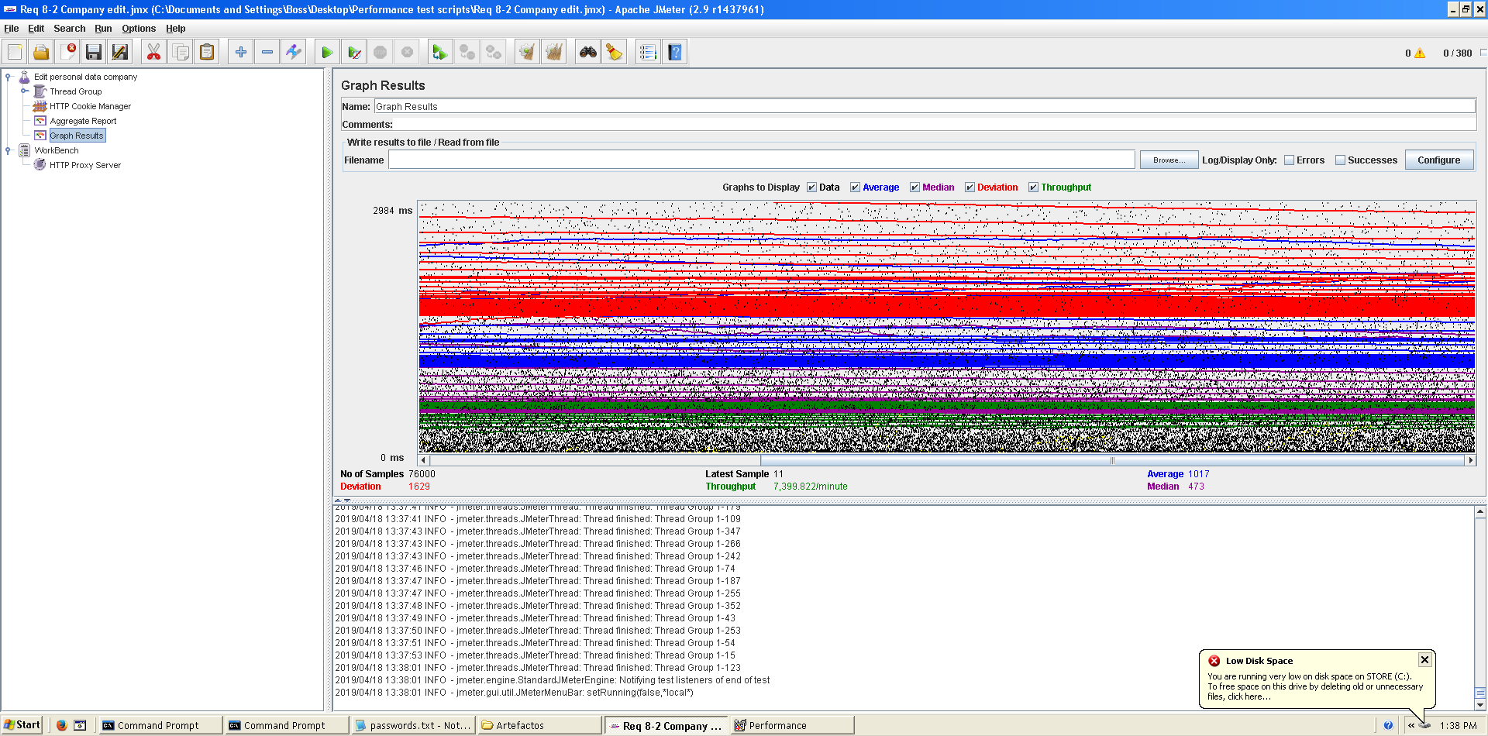

Figura 29. Graph result

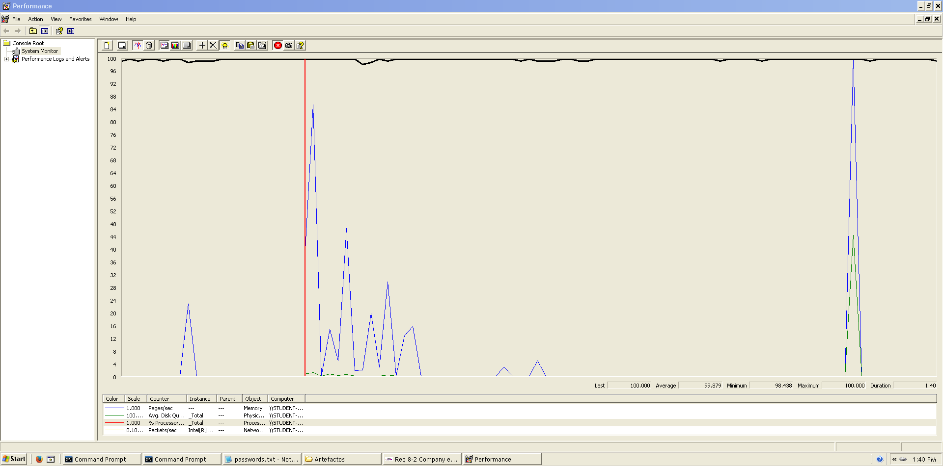As we can see in the graph below, there is a bottleneck with the CPU. Probably we could improve the maximum workload of the application if we assign more processors to the virtual machine.  
  
  
  
  
**Conclusion:** The maximum number of concurrent users supported by this test case is 370 and we could improve it by assigning more CPU’s resources to our system.  
  
  
  
  
  
  
**Req. 8.2** – An actor who is authenticated must be able to: Edit his or her personal data (hacker).

Figura 30. Bottleneck analysis

Technical details of the computer on which the test has been executed:

* Ram: 8,00 GB
* CPU: Intel Core i7-7700HQ
* Hard disk: 256 GB SSD + 921 GB HDD
* Network card: Intel(R) Dual Band Wireless-AC 3168

**Test case description**:

* The user log in the system.
* The user goes to his/her profile.
* The user goes to personal edit form.
* Change any field.
* Press save button save changes.
* Log out the system.

**Maximum workload test case.** 310 concurrent users and 20 of loop count:

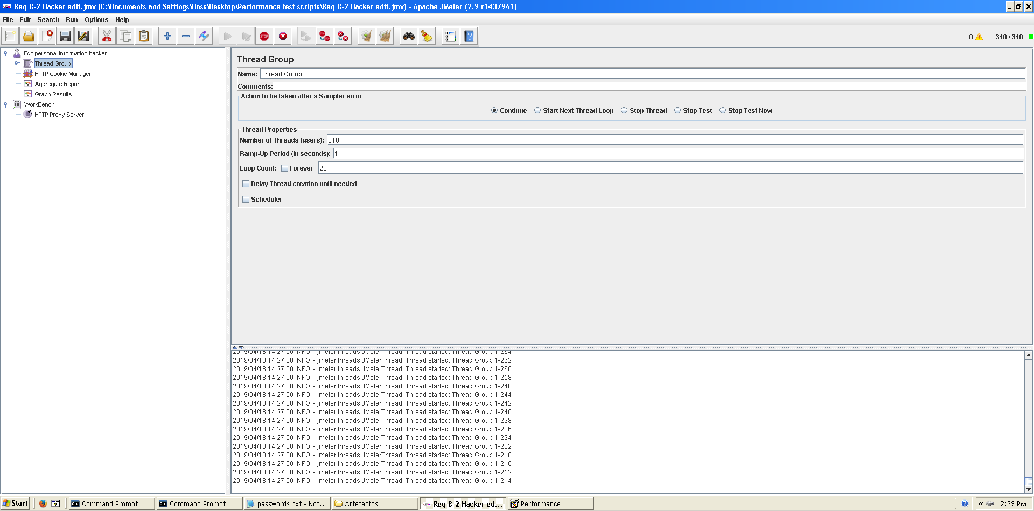

Figura 31. Configuration

This is the maximum workload of the test case without any crash or excesive delay. As we can see in the picture below, we don’t have any errors and the average time per request is pretty acceptable.

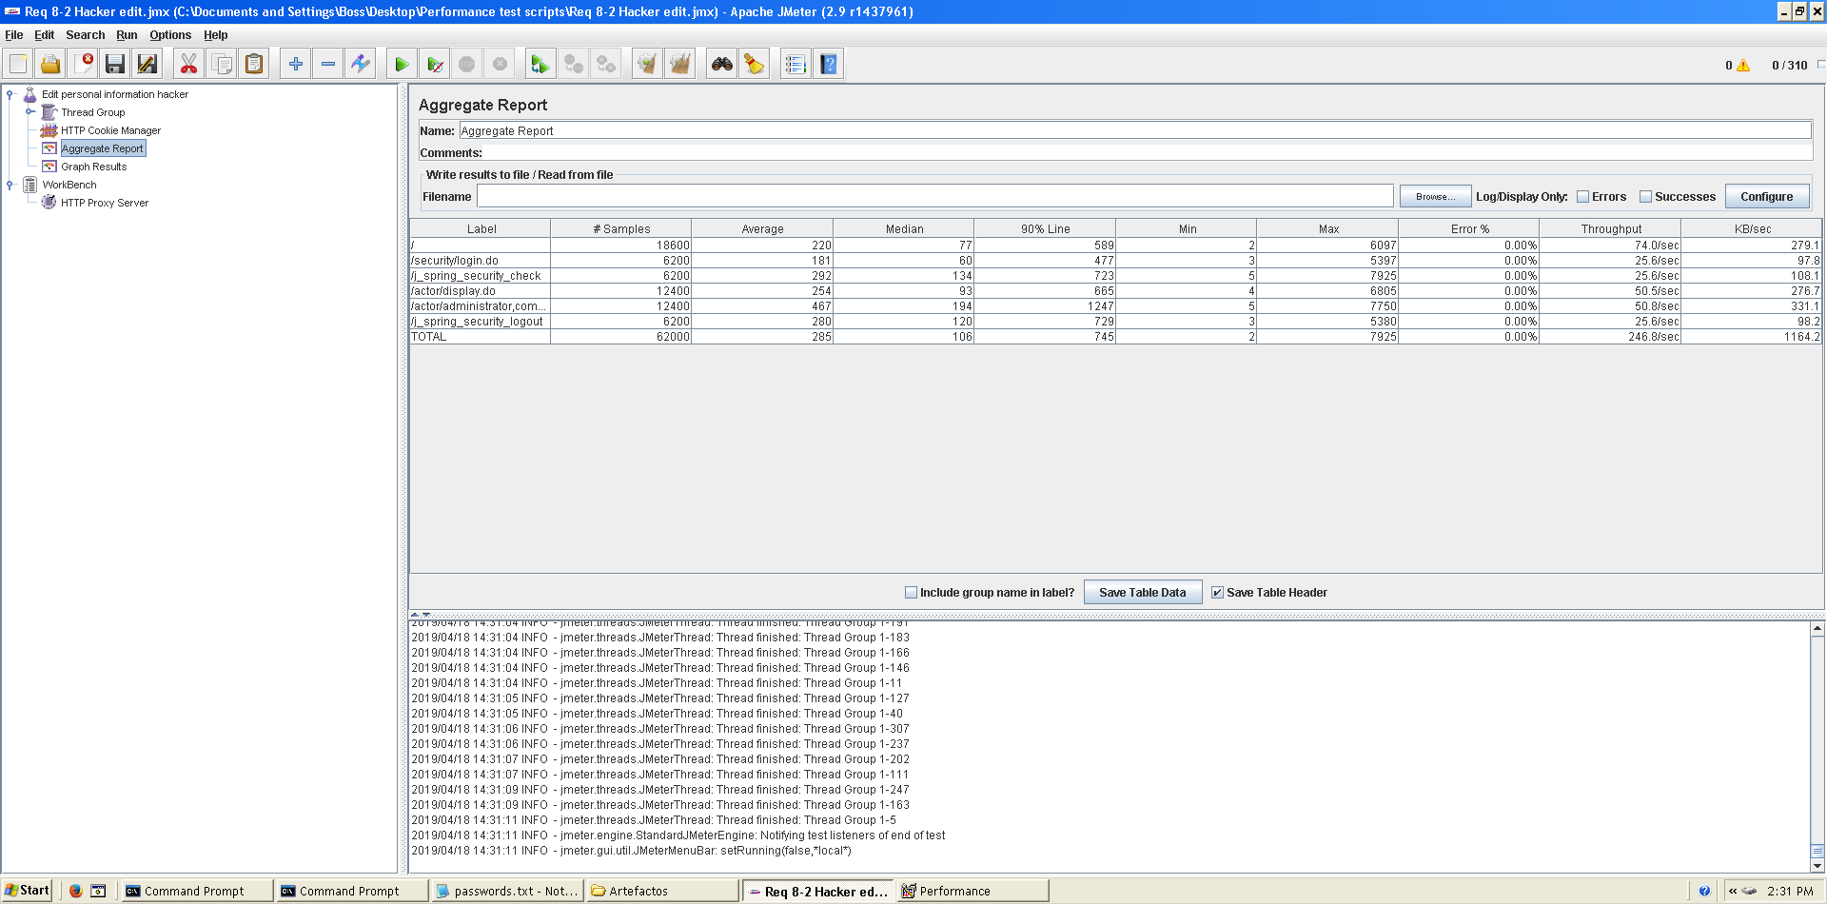

Figura 32. Aggregate Report

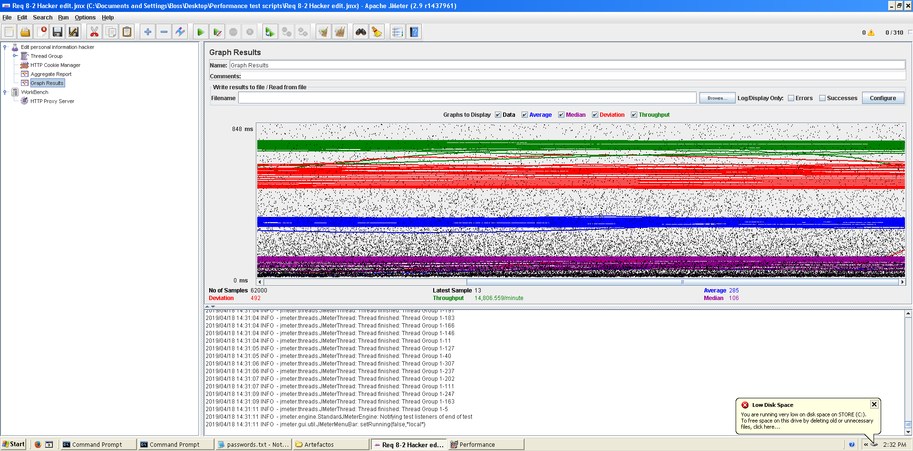

Figura 33. Graph result

**Overload test case:** 320 concurrent users and 20 of loop count:

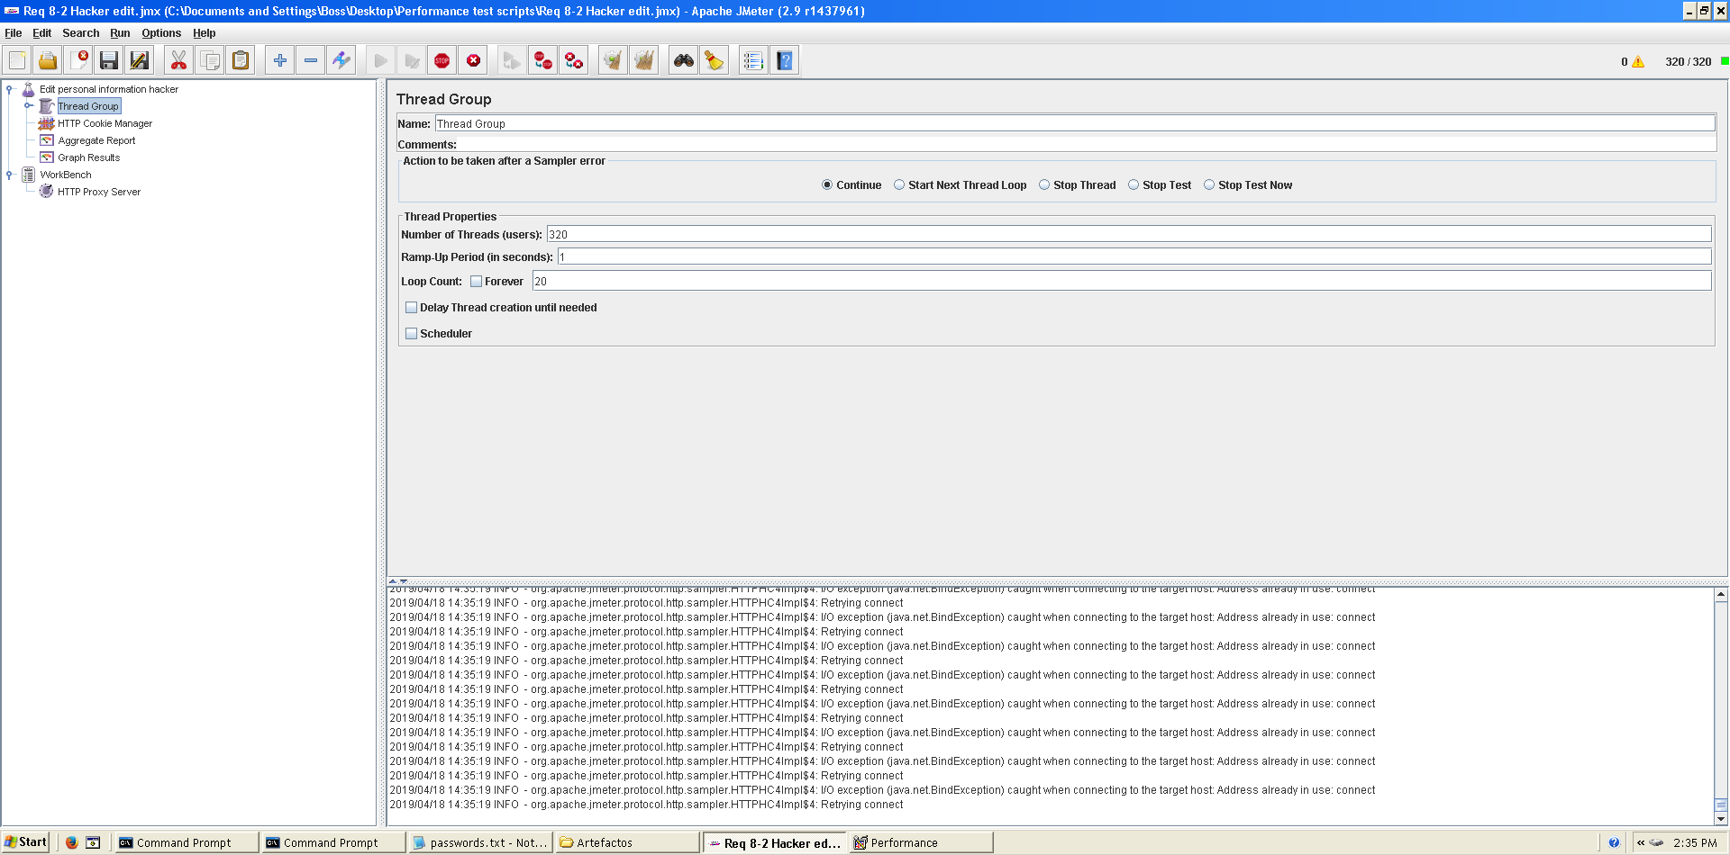

Figura 34. Configuration

It begins to produce some errors as we can see in the following picture. The errors are always the same: I/O exception (java.net.BindException) caught when connecting to the target host:

Address already in use: connect This exception is not related with the implementation of our application, but with tomcat. The system can’t handle this number of concurrent users properly.

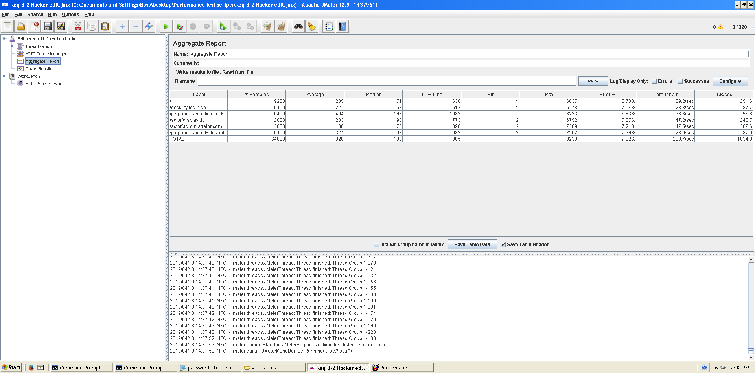

Figura 35. Aggregate Report

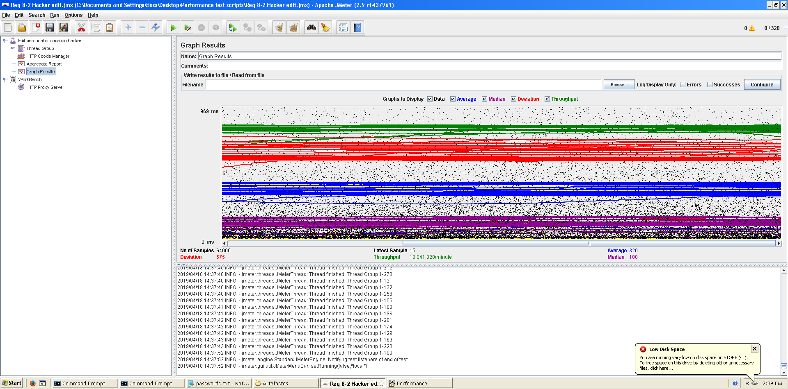

Figura 36. Graph result

As we can see in the graph below, there is a bottleneck with the CPU. Probably we could improve the maximum workload of the application if we assign more processors to the virtual machine but not improve it so much because we can see it doesn’t work always at 100%.

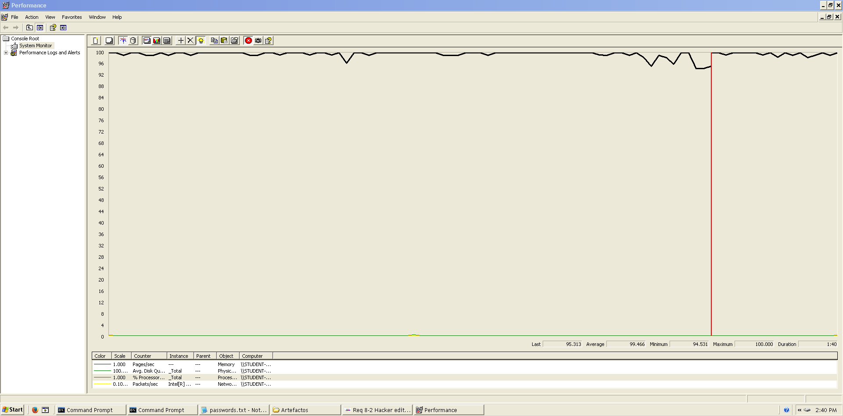

Figura 37. Bottleneck analysis

**Conclusion:** The maximum number of concurrent users supported by this test case is 310 and we could improve it by assigning more CPU’s resources to our system.

**Req. 11.1** – An actor who is authenticated as an administrator must be able to: Create user accounts for new administrators.

Technical details of the computer on which the test has been executed:

* Ram: 8,00 GB
* CPU: Intel Core i7-7700HQ
* Hard disk: 256 GB SSD + 921 GB HDD
* Network card: Intel(R) Dual Band Wireless-AC 3168

**Test case description**:

* The user logs in as an administrator.
* The user goes to register administrator view.
* The user completes register administrator form.
* The user logs out the system.
* The user logs in the system with the new admin account.
* The user logs out the system.

**Maximum workload test case.** 355 concurrent users and 20 of loop count:

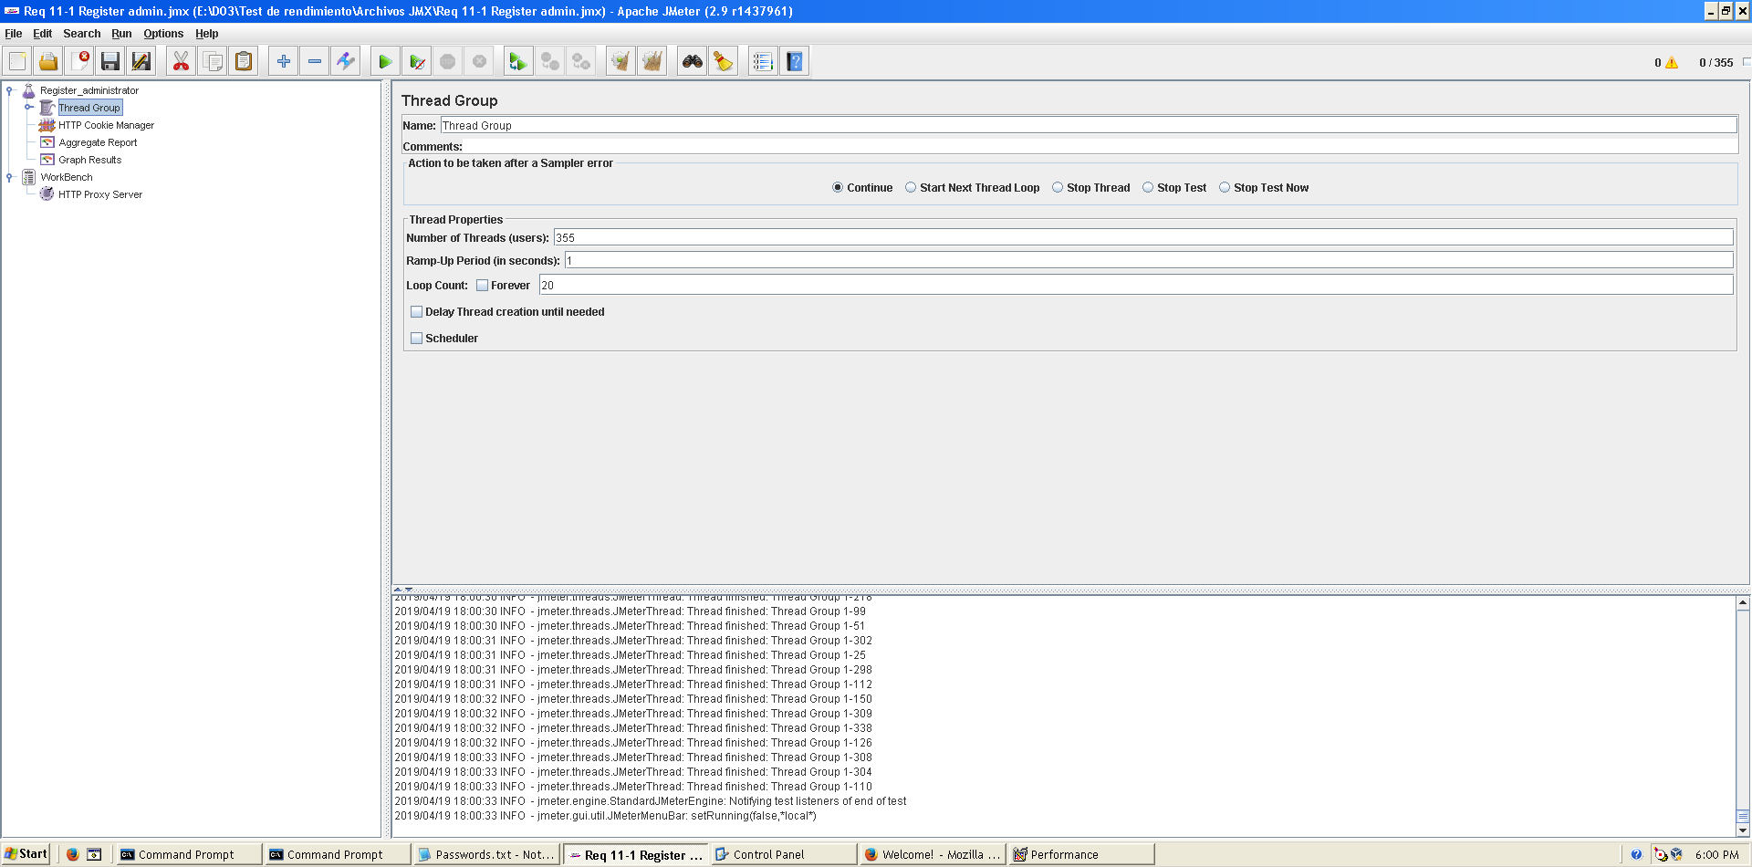

Figura 38. Configuration

This is the maximum workload of the test case without any crash or excesive delay. As we can see in the picture below, we don’t have any errors and the average time per request is pretty acceptable.

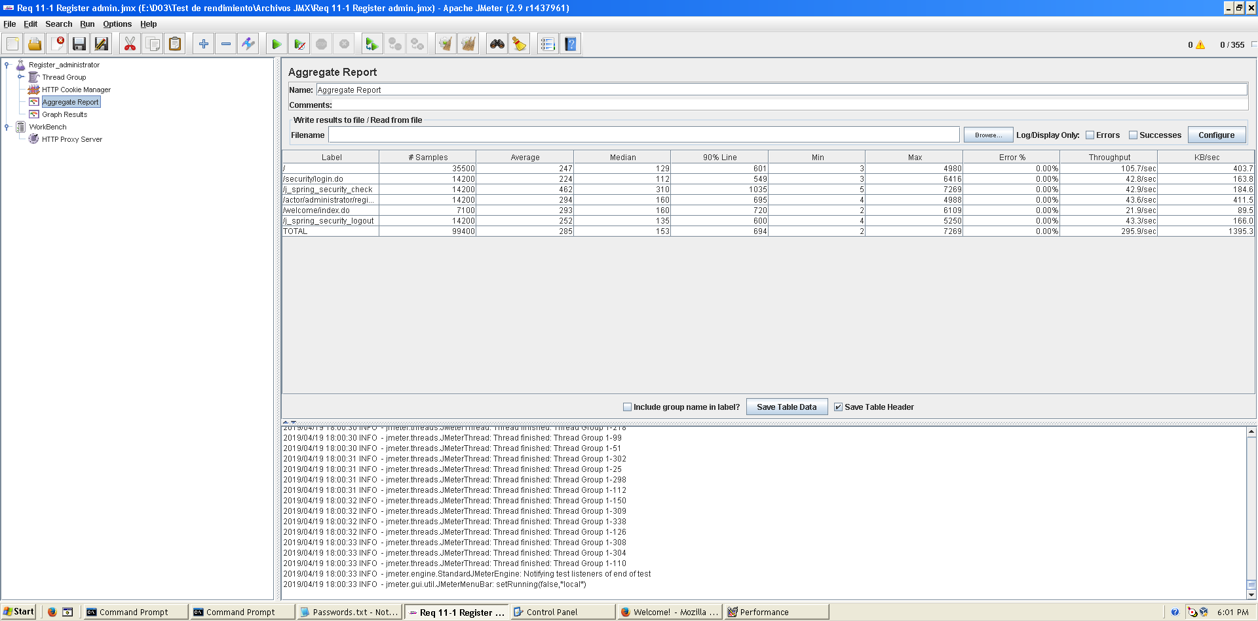

Figura 39. Aggregate Report

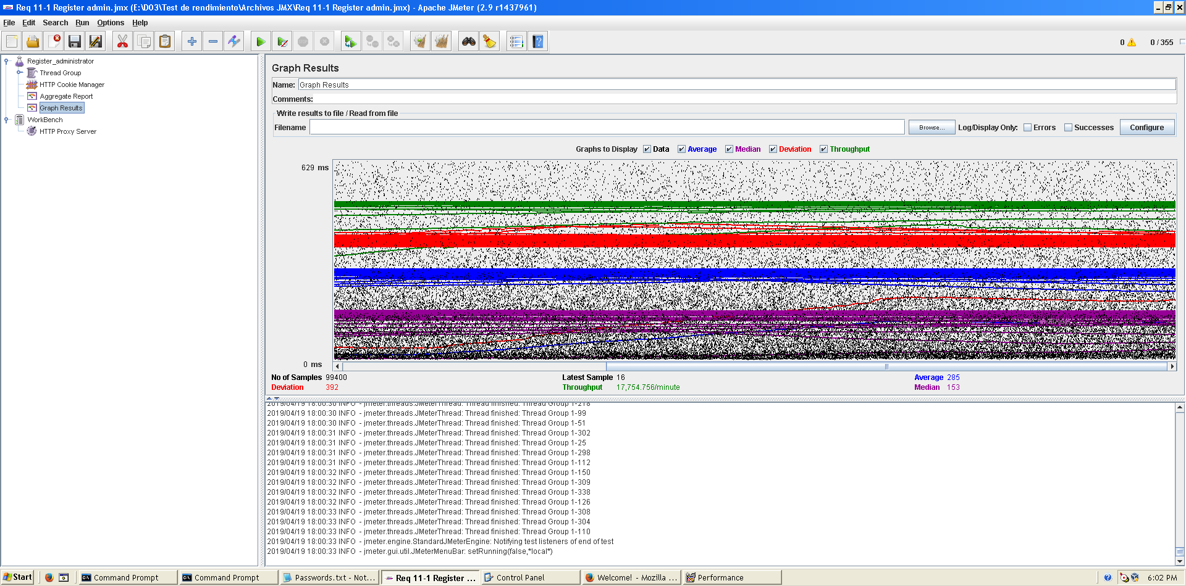**Overload test case:** 365 concurrent users and 20 of loop count:

Figura 40. Graph result

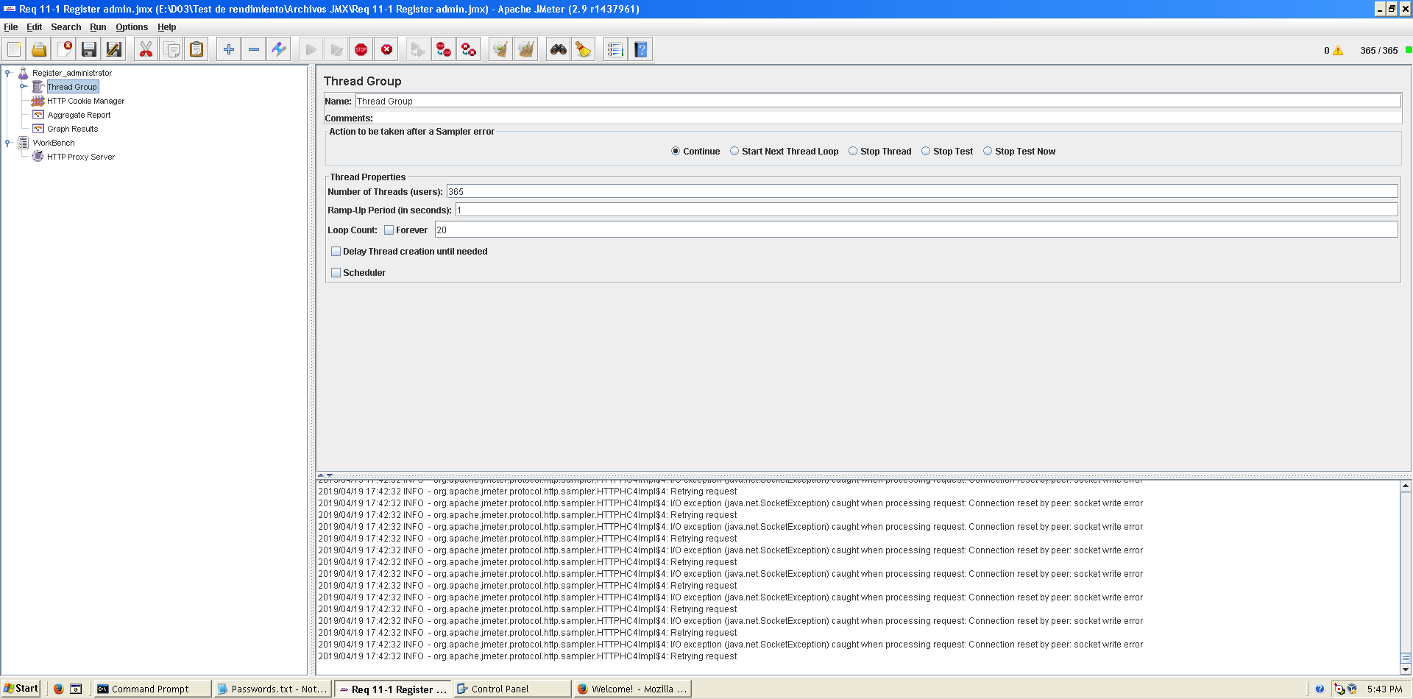

Figura 41. Configuration

Even though the average time per request is still acceptable, it begins to produce some errors as we can see in the following picture. The errors are always the same: I/O exception (java.net.SocketException) caught when processing request: Connection reset by peer: socket write error This exception is not related with the implementation of our application, but with tomcat. The system can’t handle this number of concurrent users properly.

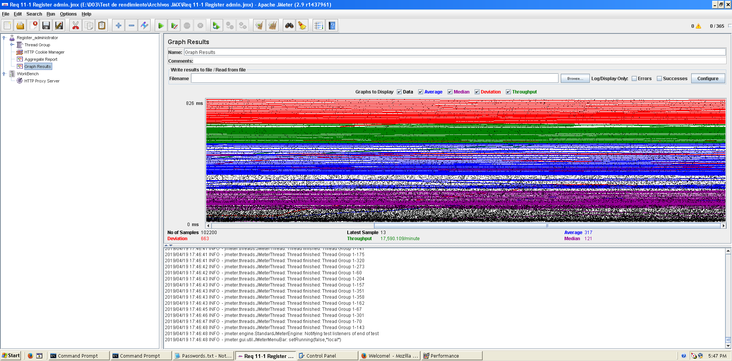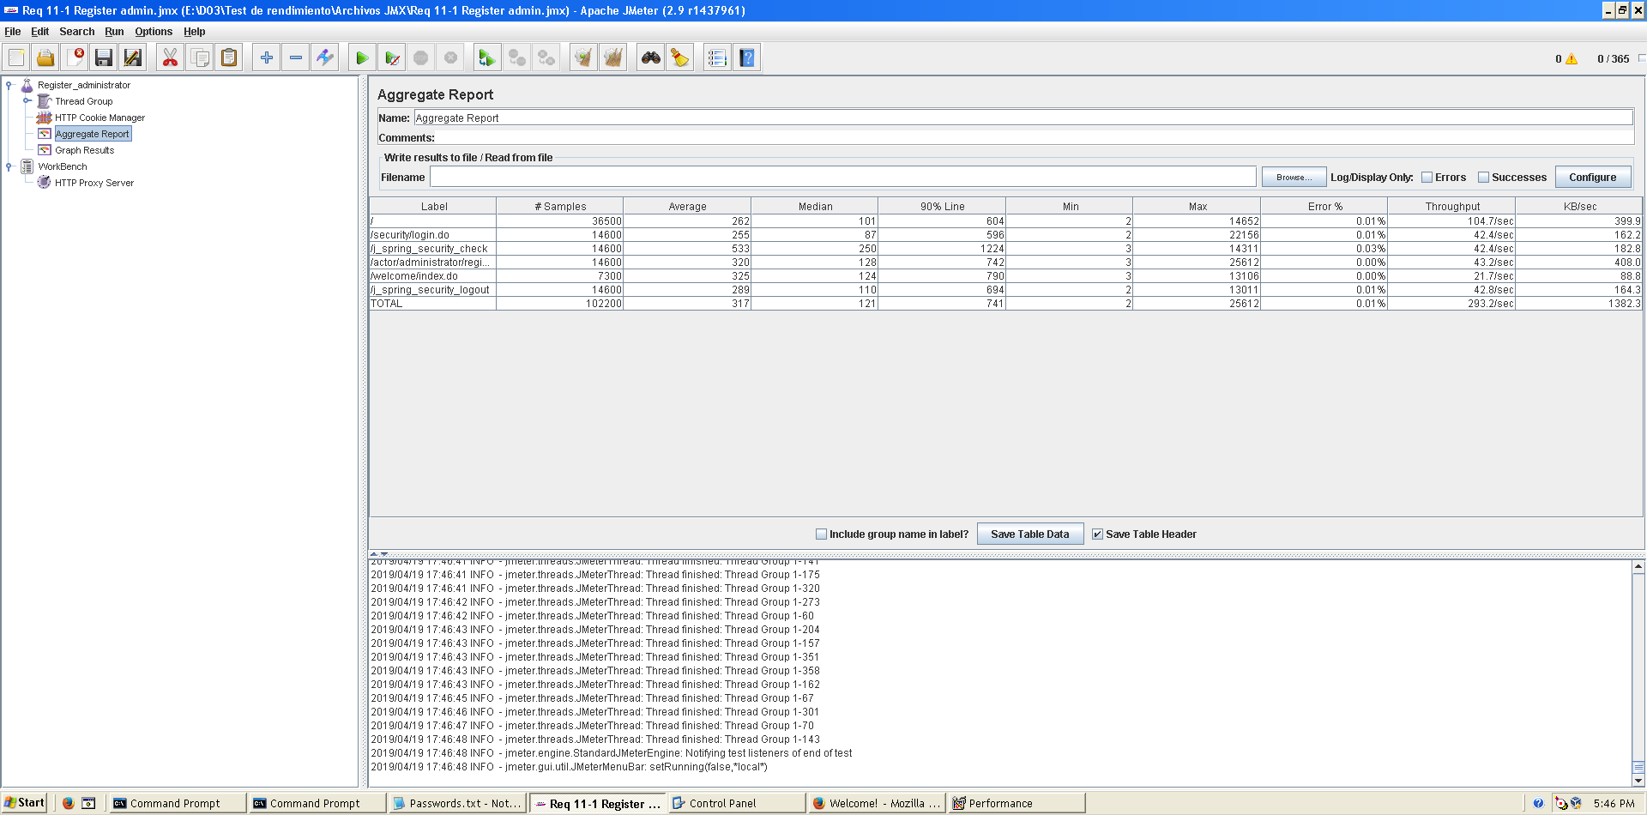

Figura 42. Graph result

Figura 43. Aggregate Report

As we can see in the graph below, there is a bottleneck with the CPU. Probably we could improve the maximum workload of the application if we assign more processors to the virtual machine.

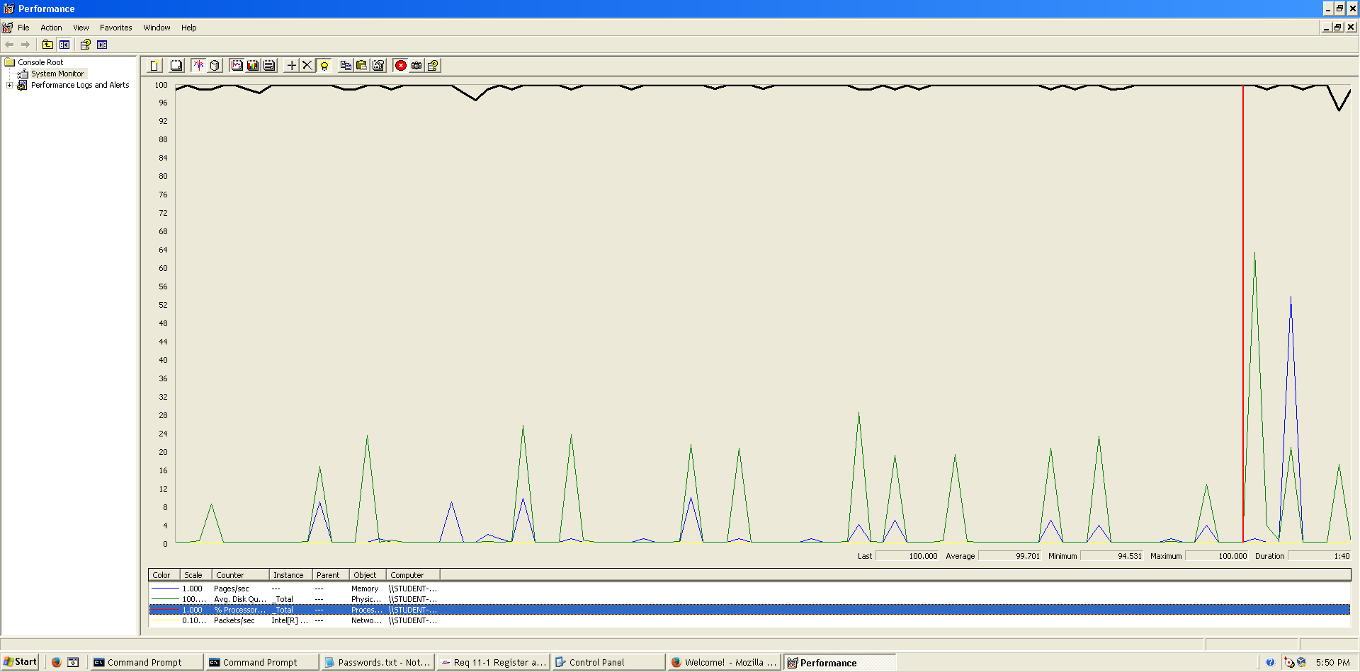

Figura 44. Bottleneck analysis

**Conclusion:** The maximum number of concurrent users supported by this test case is 355 and we could improve it by assigning more CPU’s resources to our system.

**Req. 11.2** – An actor who is authenticated as an administrator must be able to: Display a dashboard.

Technical details of the computer on which the test has been executed:

* Ram: 8,00 GB
* CPU: Intel Core i7-7700HQ
* Hard disk: 256 GB SSD + 921 GB HDD
* Network card: Intel(R) Dual Band Wireless-AC 3168

**Test case description**:

* The user logs in as an administrator.
* The user goes to dashboard view.
* The user logs out the system.

**Maximum workload test case.** 390 concurrent users and 20 of loop count:

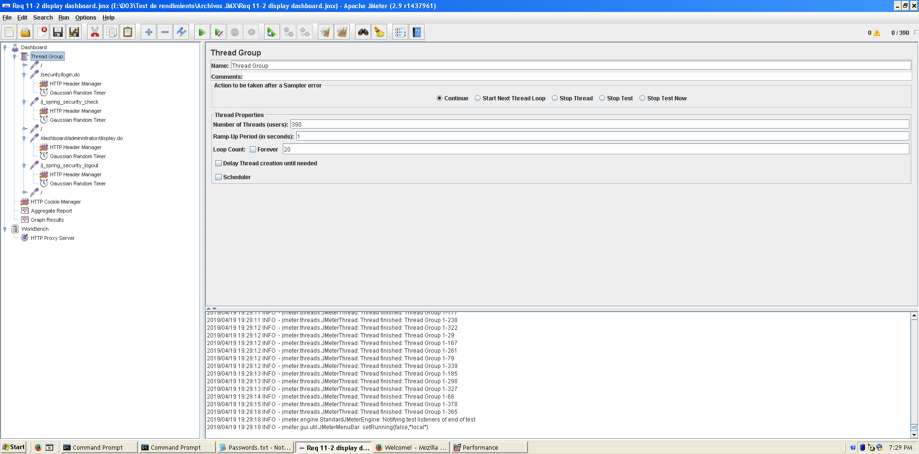

Figura 45. Configuration

This is the maximum workload of the test case without any crash or excesive delay. As we can see in the picture below, we don’t have any errors and the average time per request is pretty acceptable.

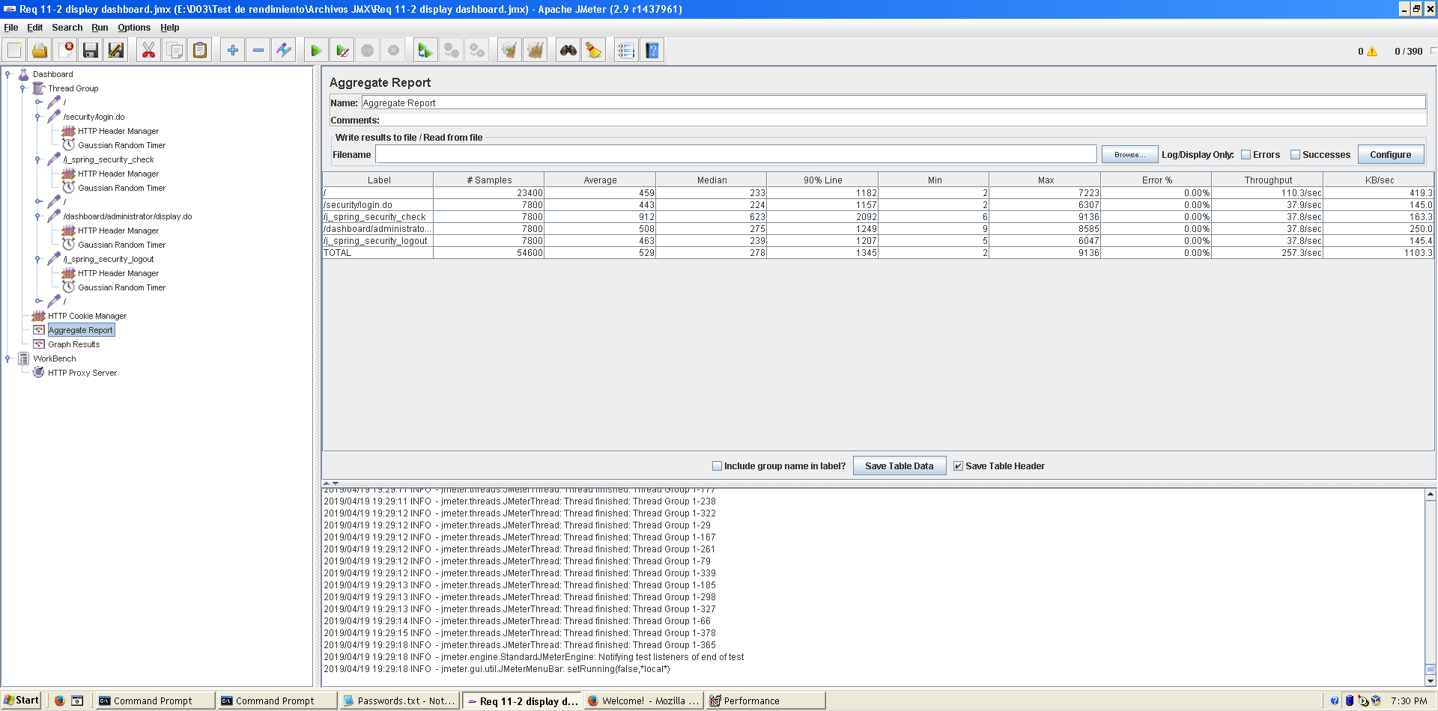

Figura 46. Aggregate Report

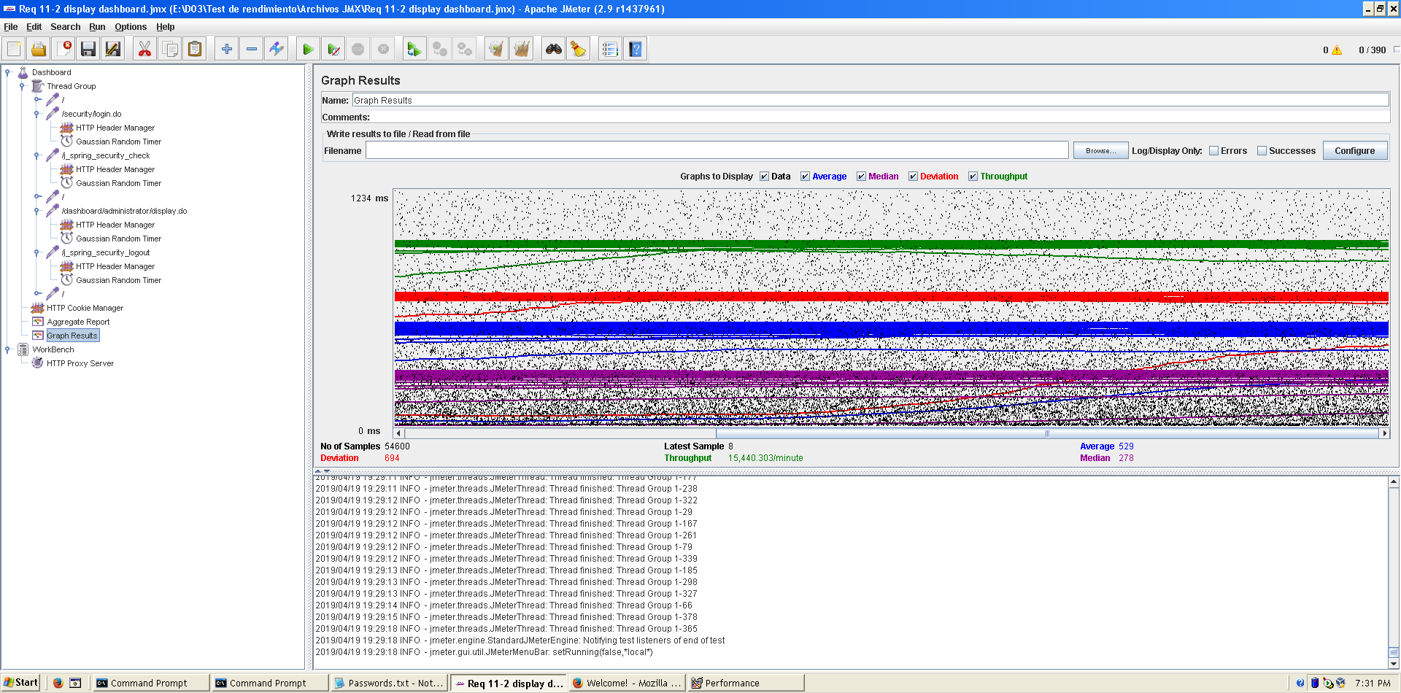  
  
**Overload test case:** 400 concurrent users and 20 of loop count:

Figura 47. Graph result

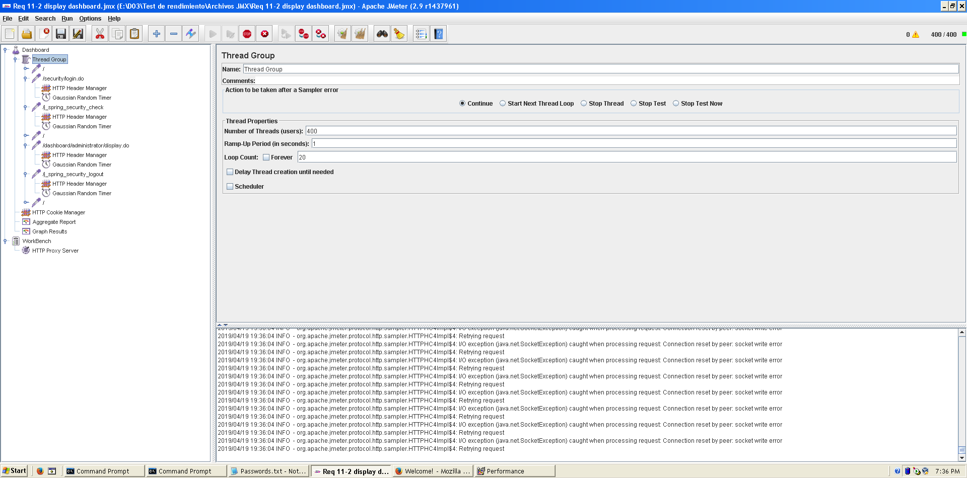

Figura 48. Configuration

Even though the average time per request is still acceptable, it begins to produce some errors as we can see in the following picture. The errors are always the same: I/O exception (java.net.SocketException) caught when processing request: Connection reset by peer: socket write error This exception is not related with the implementation of our application, but with tomcat. The system can’t handle this number of concurrent users properly.

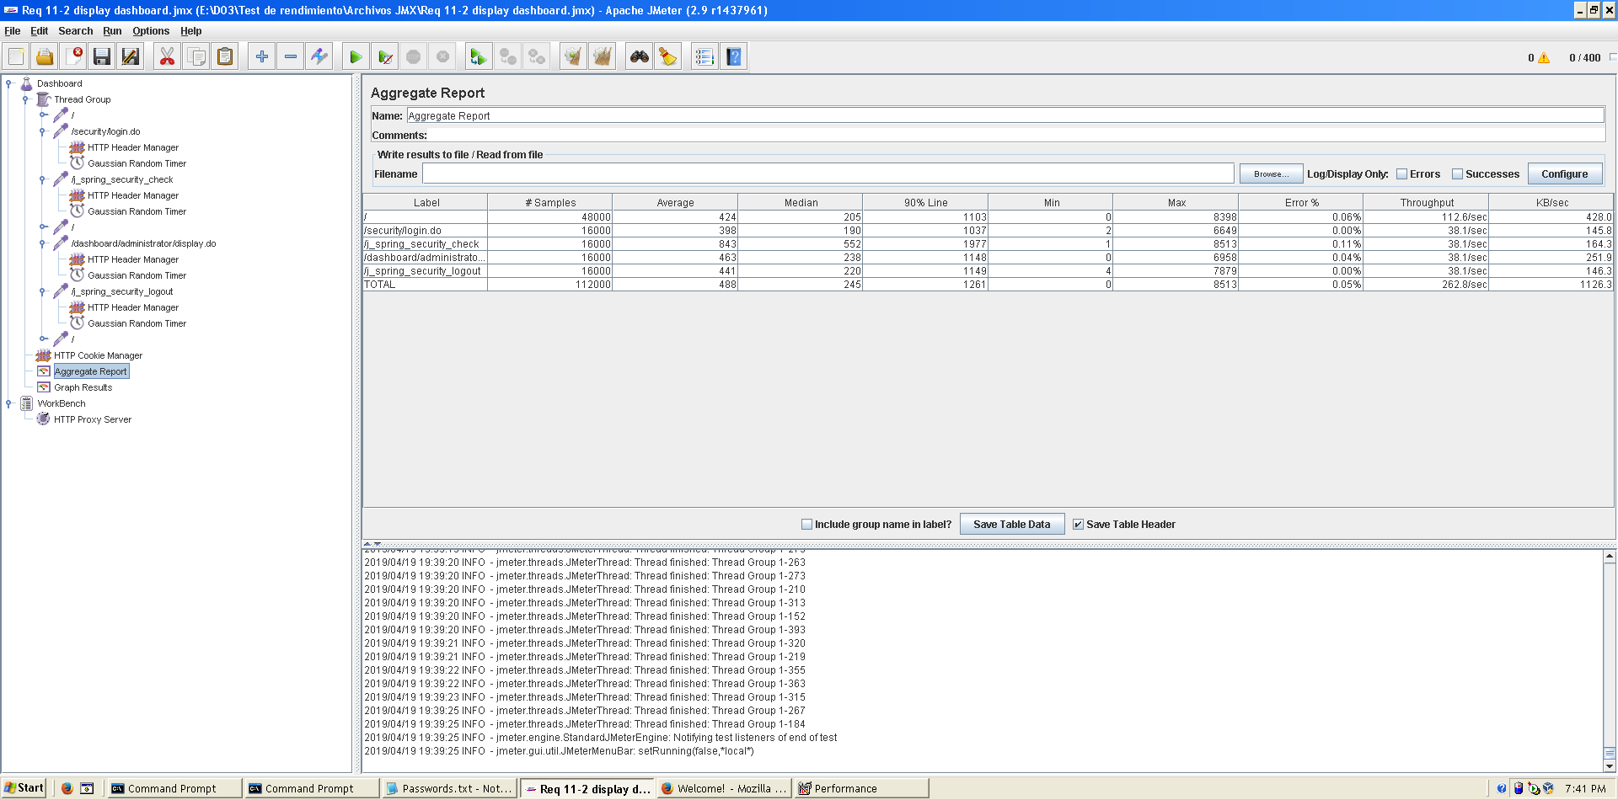

Figura 49. Aggregate Report

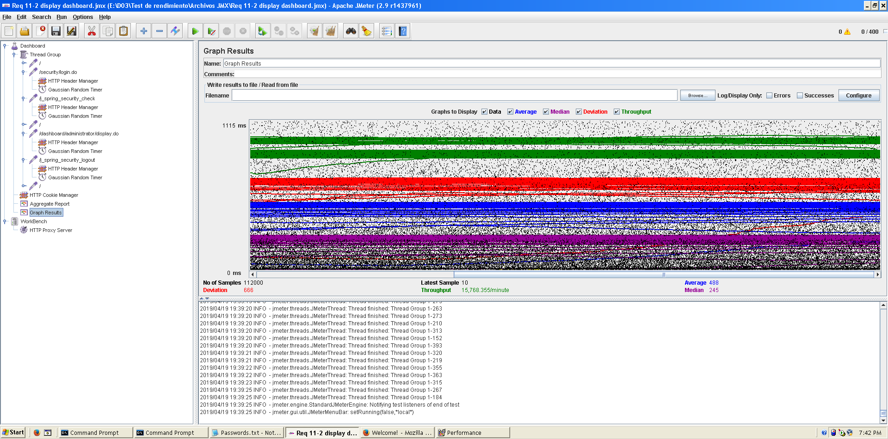

Figura 50. Graph result

As we can see in the graph below, there is a bottleneck with the CPU. Probably we could improve the maximum workload of the application if we assign more processors to the virtual machine.

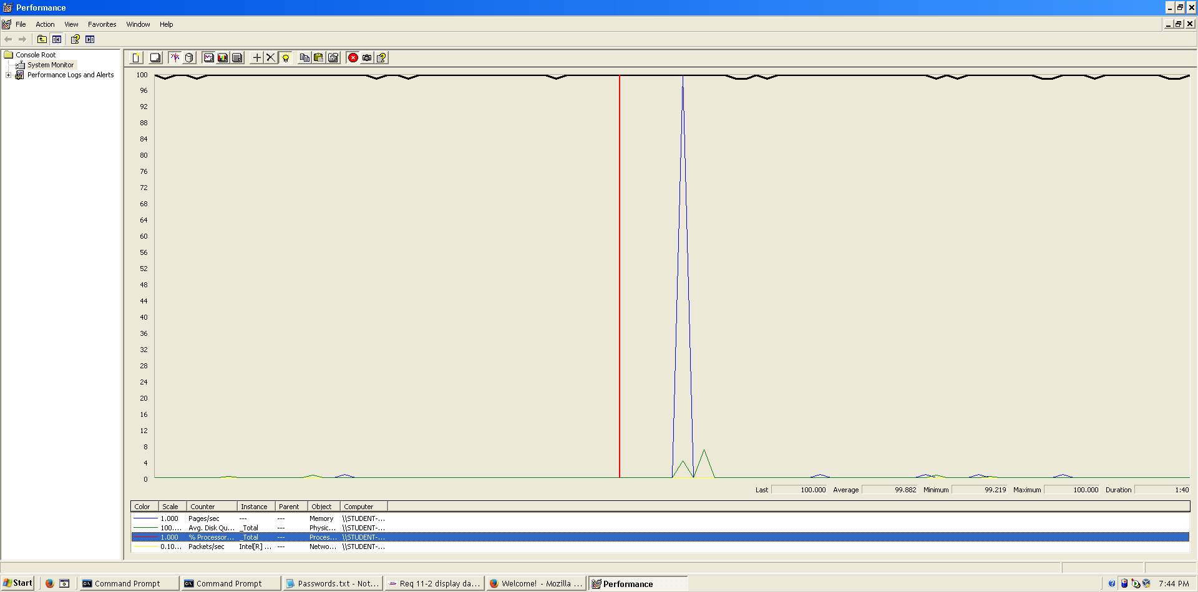

Figura 51. Bottleneck analysis

**Conclusion:** The maximum number of concurrent users supported by this test case is 390 and we could improve it by assigning more CPU’s resources to our system.

**Req. 24.3** – An actor who is authenticated as an administrator must be able to: Ban an actor with the spammer flag.

Technical details of the computer on which the test has been executed:

* Ram: 8,00 GB
* CPU: Intel Core i7-7700HQ
* Hard disk: 256 GB SSD + 921 GB HDD
* Network card: Intel(R) Dual Band Wireless-AC 3168

**Test case description**:

* The user logs in as an administrator.
* The user goes to actor list view.
* The user launchs spammer process.
* The user display the profile of actor who has spammer flag.
* The user bans the actor
* The user logs out the system.

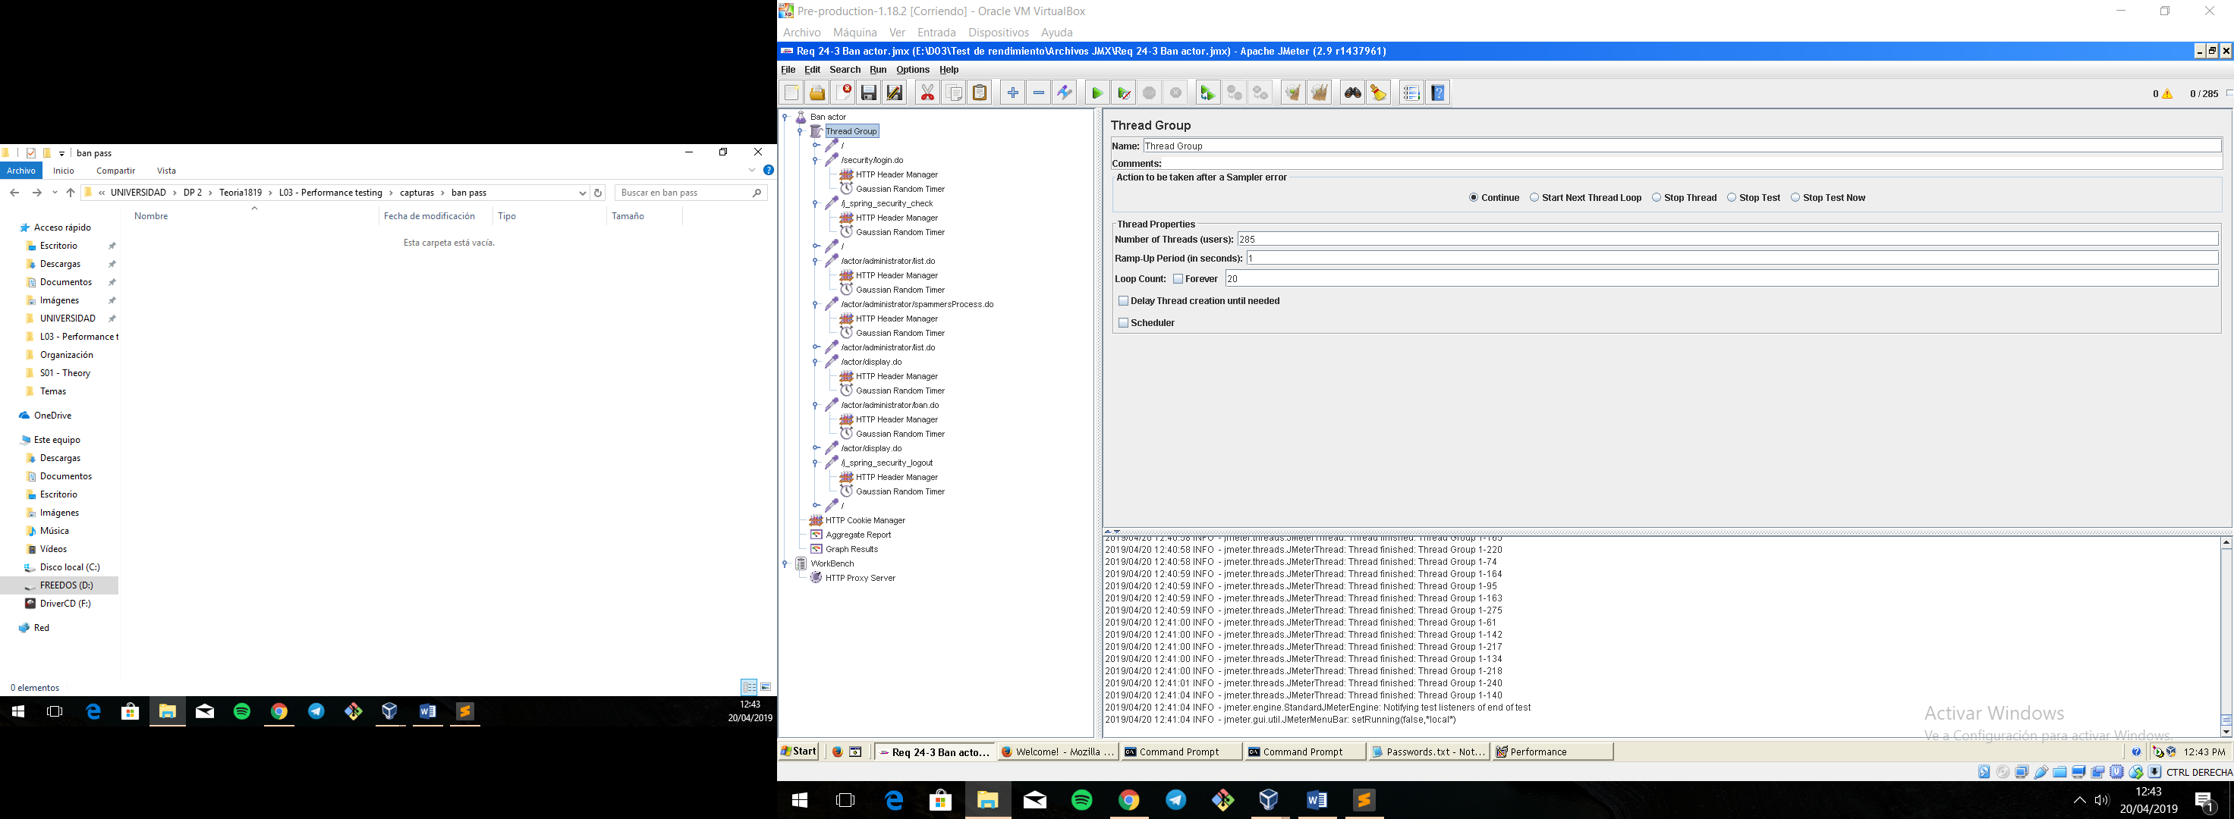**Maximum workload test case.** 285 concurrent users and 20 of loop count:

Figura 52. Configuration

Figura 53. Configuration

This is the maximum workload of the test case without any crash or excesive delay. As we can see in the picture below, we don’t have any errors and the average time per request is pretty acceptable.

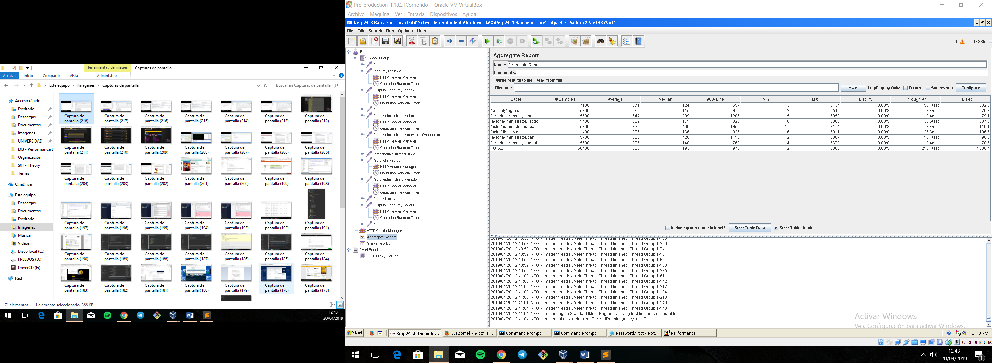

Figura 54. Aggregate Report

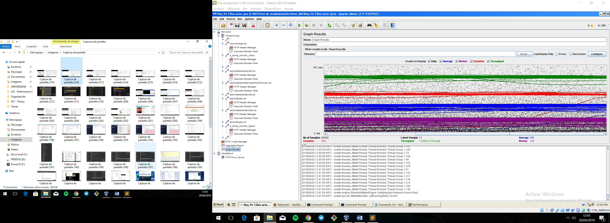

Figura 55. Graph result

Figura 56. Graph result

**Overload test case:** 295 concurrent users and 20 of loop count:

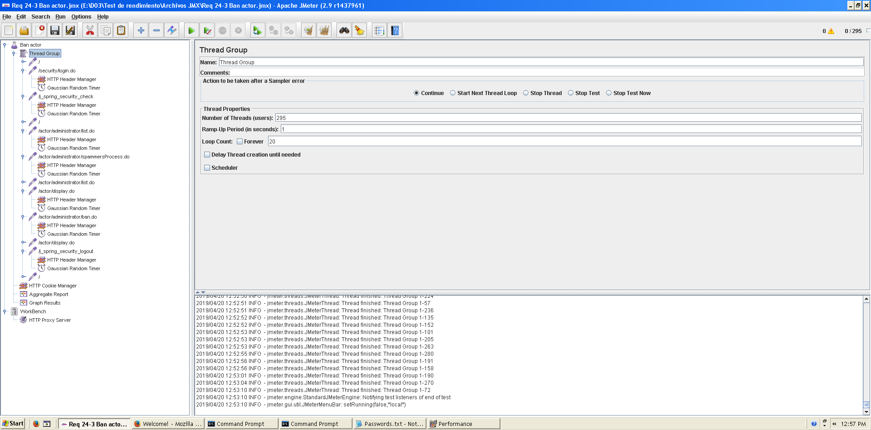

Figura 57. Configuration

We don’t have any errors, but the system works with excessive delay.

As we can see in the table below, the request with the highest average time is /actor/administrator/spammerProcess. This URI correspond to a method that goes over all the actors of the system and analyze their messages to set spammer flags so we can improve and refactoring the code to increase the users.

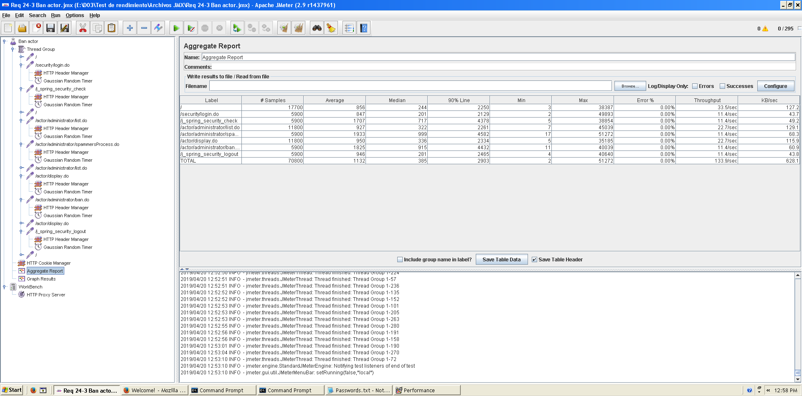

Figura 58. Aggregate Report

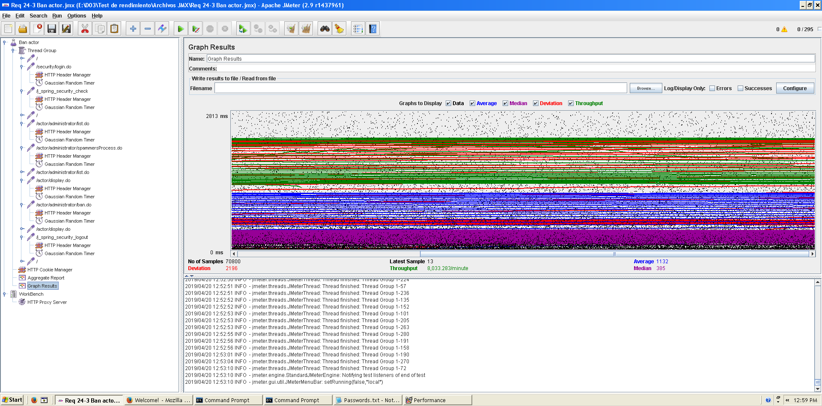

Figura 59. Graph result

As we can see in the graph below, there is a bottleneck with the CPU. Probably we could improve the maximum workload of the application if we assign more processors to the virtual machine.

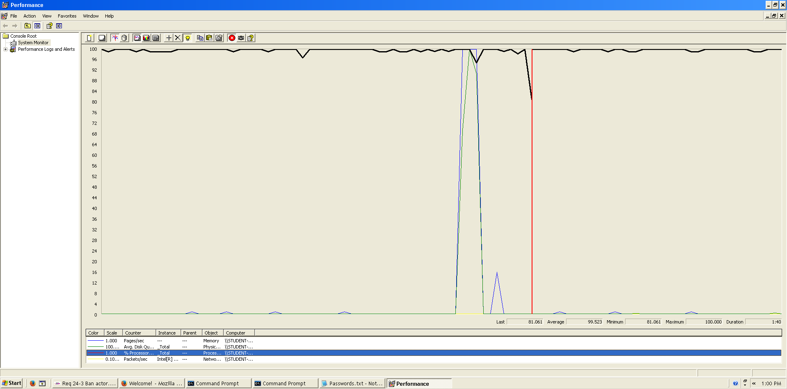

Figura 60. Bottleneck analysis

**Conclusion:** The maximum number of concurrent users supported by this test case is 285 and we could improve it by assigning more CPU’s resources to our system and refactoring our code to try to increase the number of concurrent users.

**Req. 24.4** – An actor who is authenticated as an administrator must be able to: Unban an actor with the spammer flag.

Technical details of the computer on which the test has been executed:

* Ram: 8,00 GB
* CPU: Intel Core i7-7700HQ
* Hard disk: 256 GB SSD + 921 GB HDD
* Network card: Intel(R) Dual Band Wireless-AC 3168

**Test case description**:

* The user logs in as an administrator.
* The user goes to actor list view.
* The user display the profile of actor who has banned previously.
* The user unbans the actor
* The user logs out the system.

**Maximum workload test case.** 400 concurrent users and 20 of loop count:

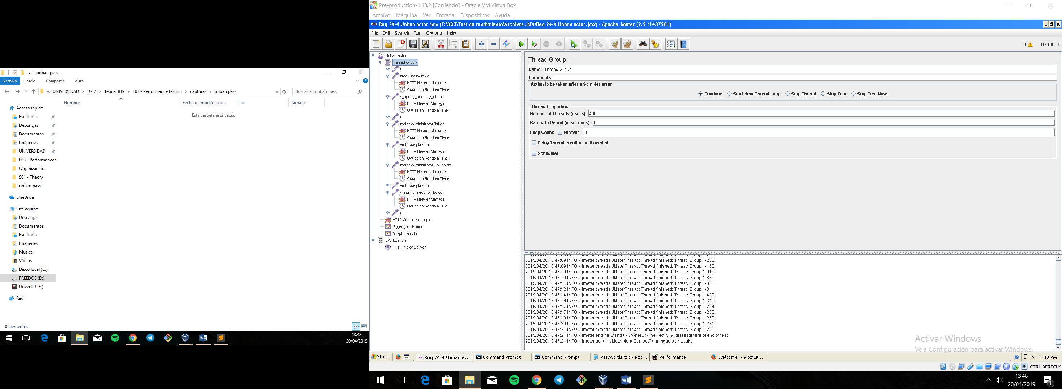

Figura 61. Configuration

This is the maximum workload of the test case without any crash or excesive delay. As we can see in the picture below, we don’t have any errors and the average time per request is pretty acceptable.

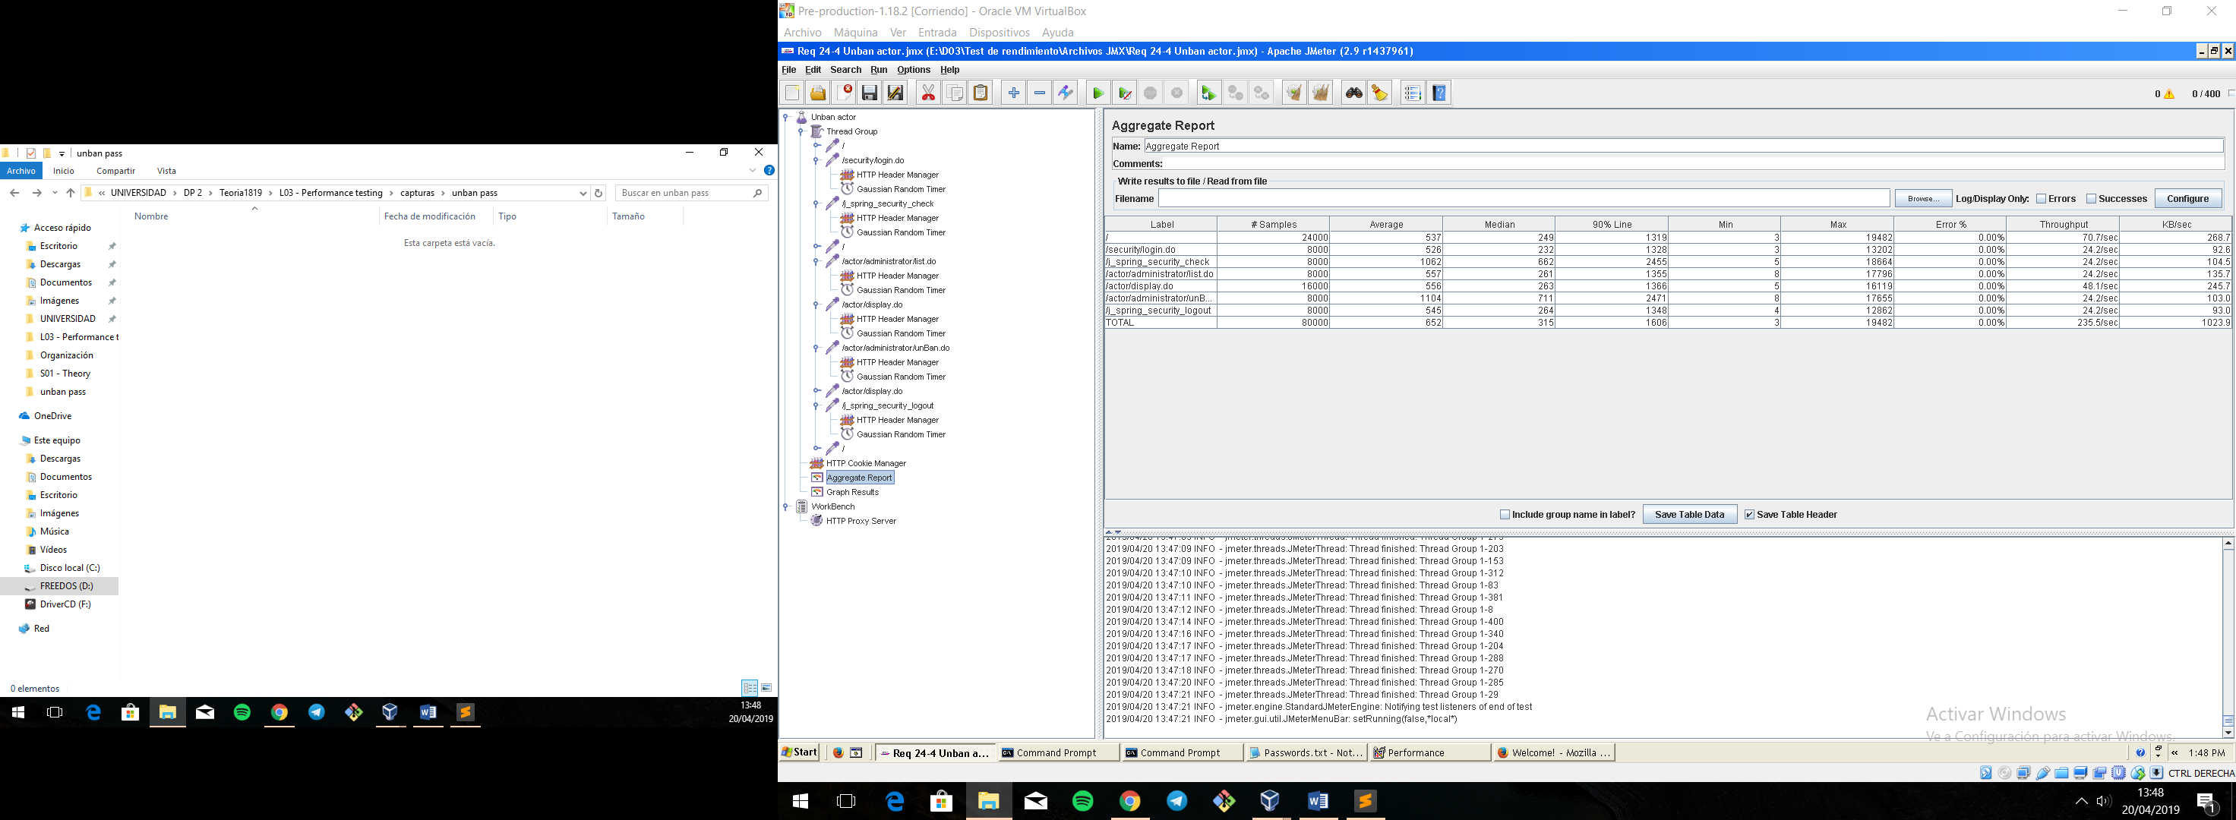

Figura 62. Aggregate Report

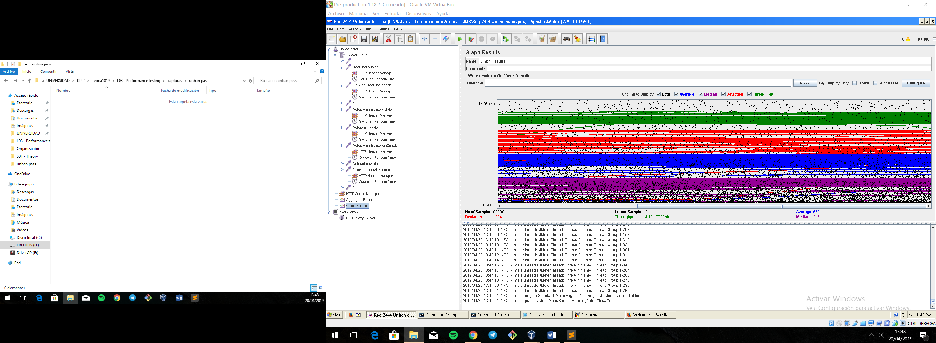

Figura 63. Graph result

**Overload test case:** 410 concurrent users and 20 of loop count:

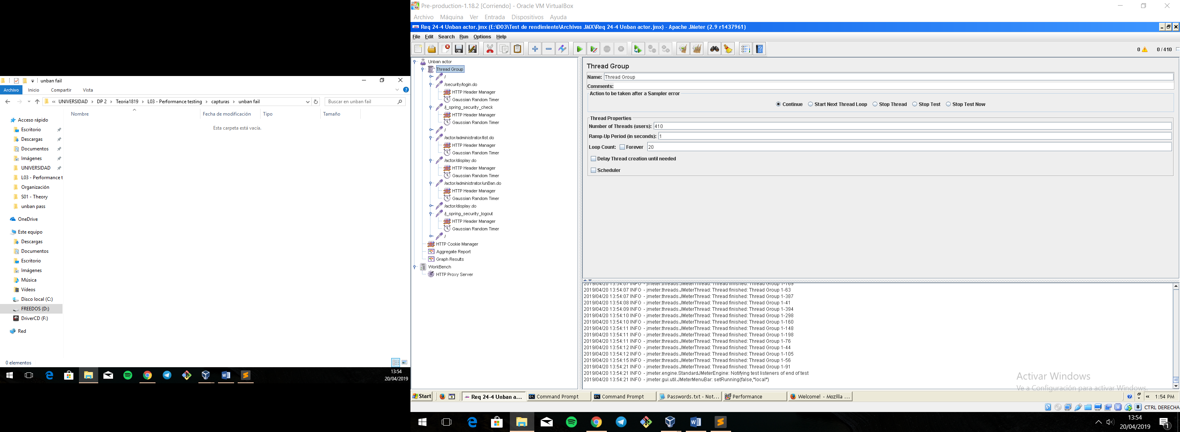

Figura 64. Configuration

Even though the average time per request is still acceptable, it begins to produce some errors as we can see in the following picture. The errors are always the same: I/O exception (java.net.SocketException) caught when processing request: Connection reset by peer: socket write error This exception is not related with the implementation of our application, but with tomcat. The system can’t handle this number of concurrent users properly.

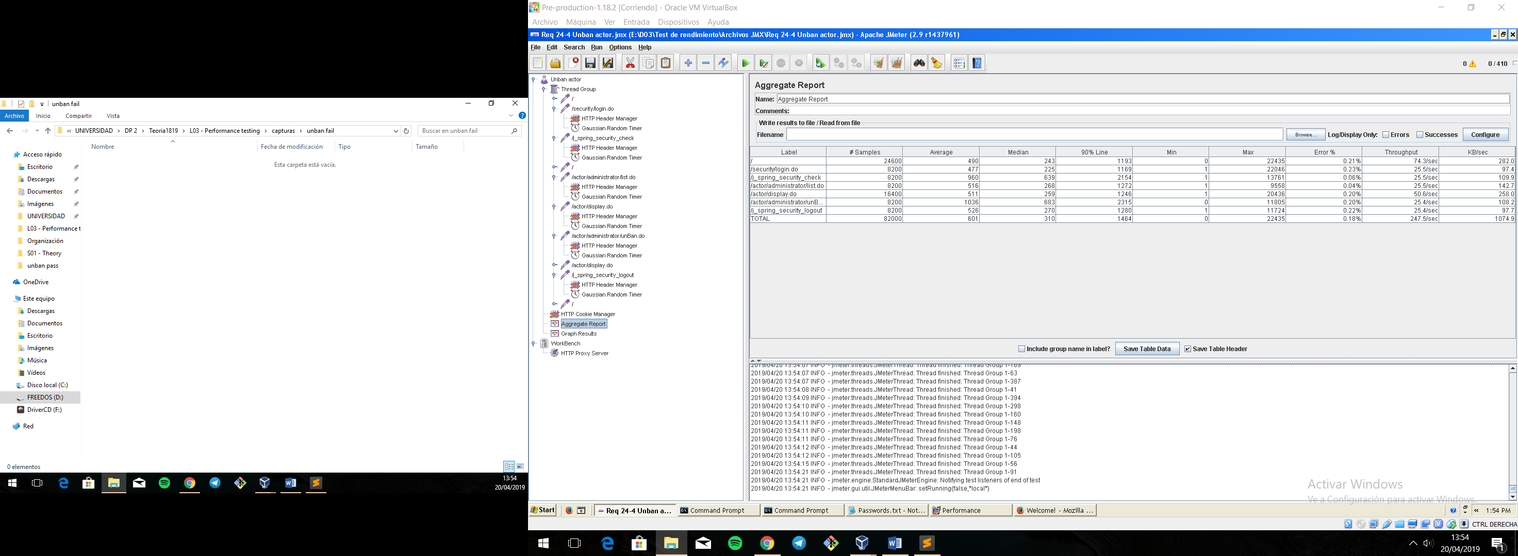

Figura 65. Aggregate Report

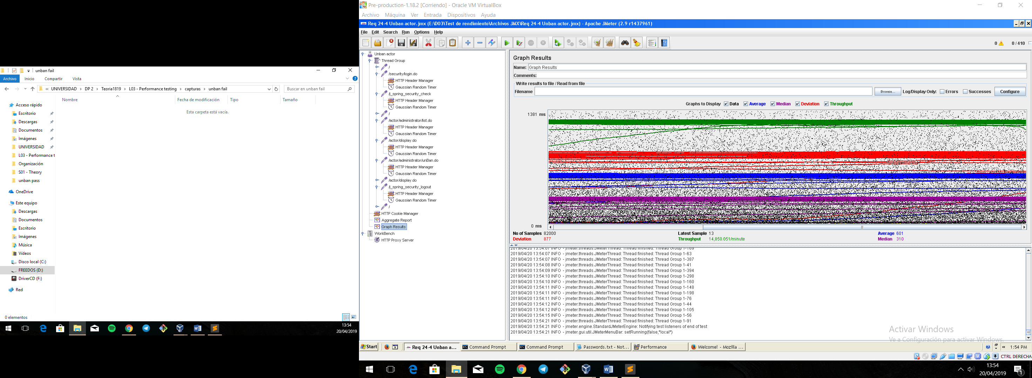

Figura 66. Graph result

As we can see in the graph below, there is a bottleneck with the CPU. Probably we could improve the maximum workload of the application if we assign more processors to the virtual machine.

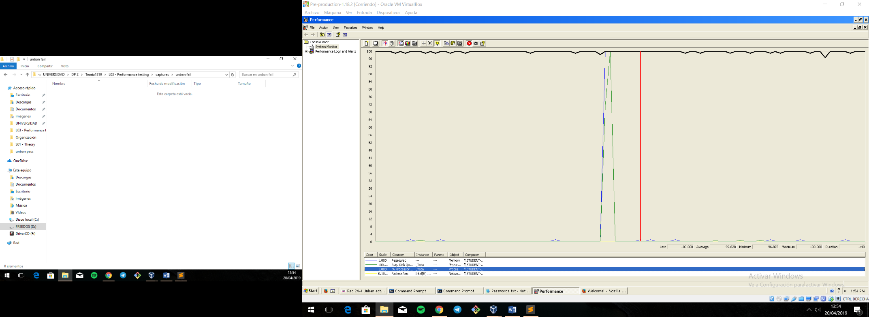

Figura 67. Bottleneck analysis

**Conclusion:** The maximum number of concurrent users supported by this test case is 400 and we could improve it by assigning more CPU’s resources to our system.